Electricity Dataset Visualation

# Foley_2019.csv

Entire_Dataset_Plot.png

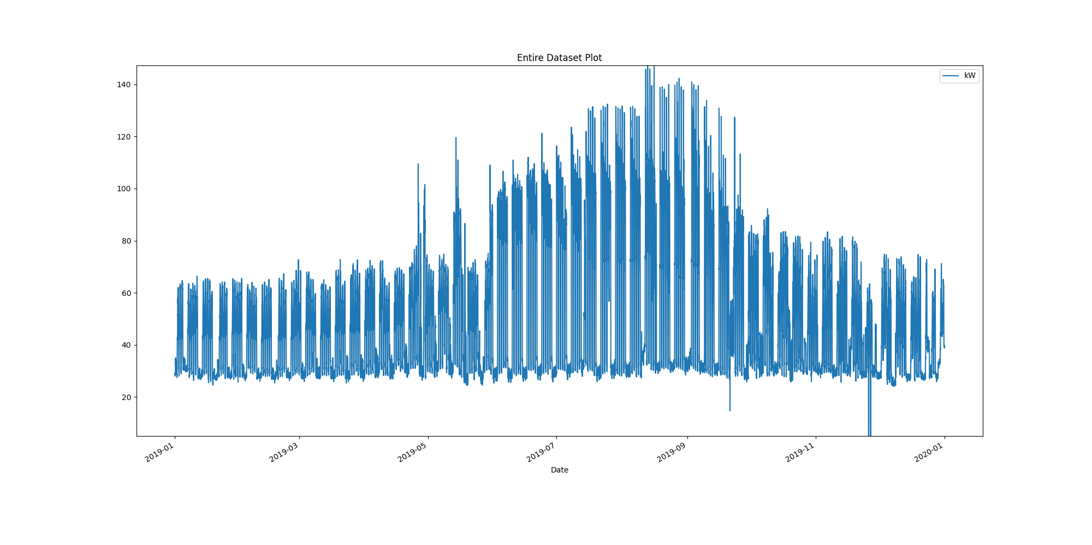

# Plot of month with max demand recorded

Month_maximum_recorded_demand.png

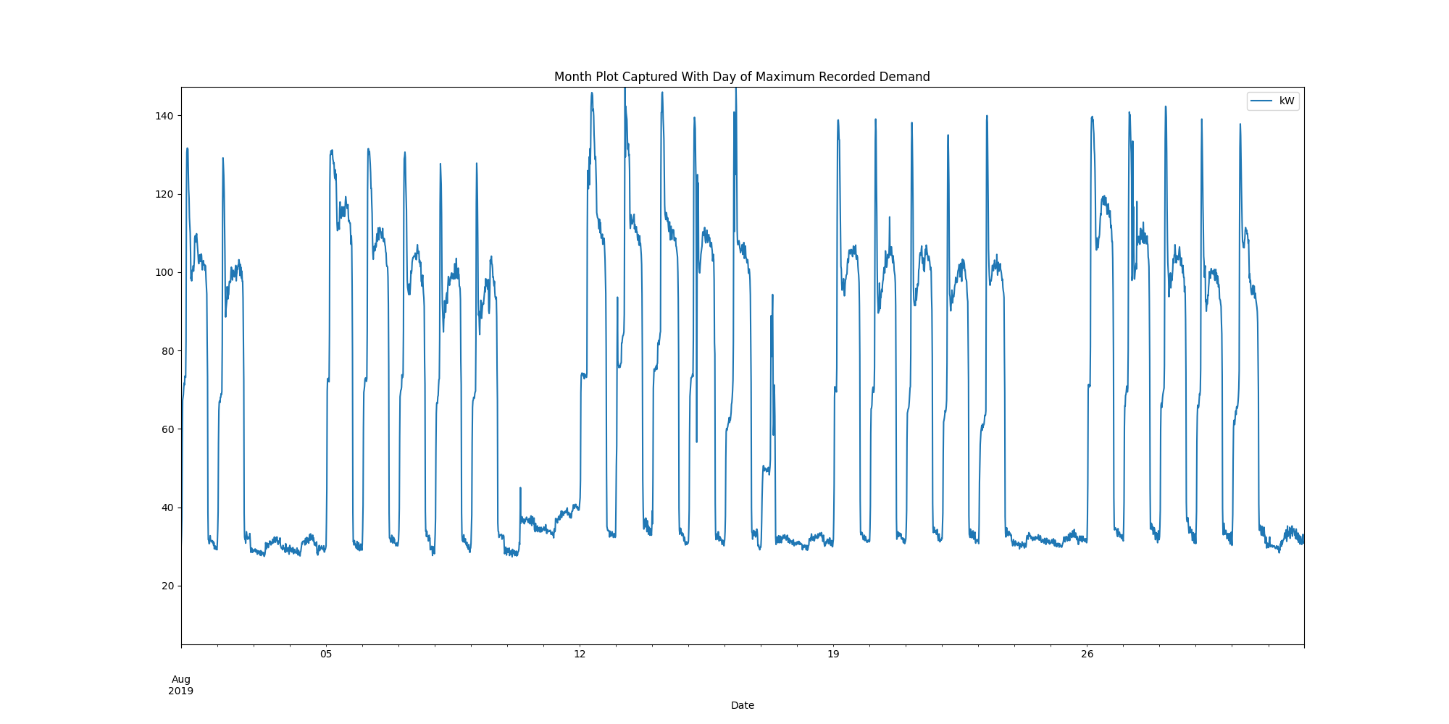

# Power box plots per month

AllDatakWboxPlots.png

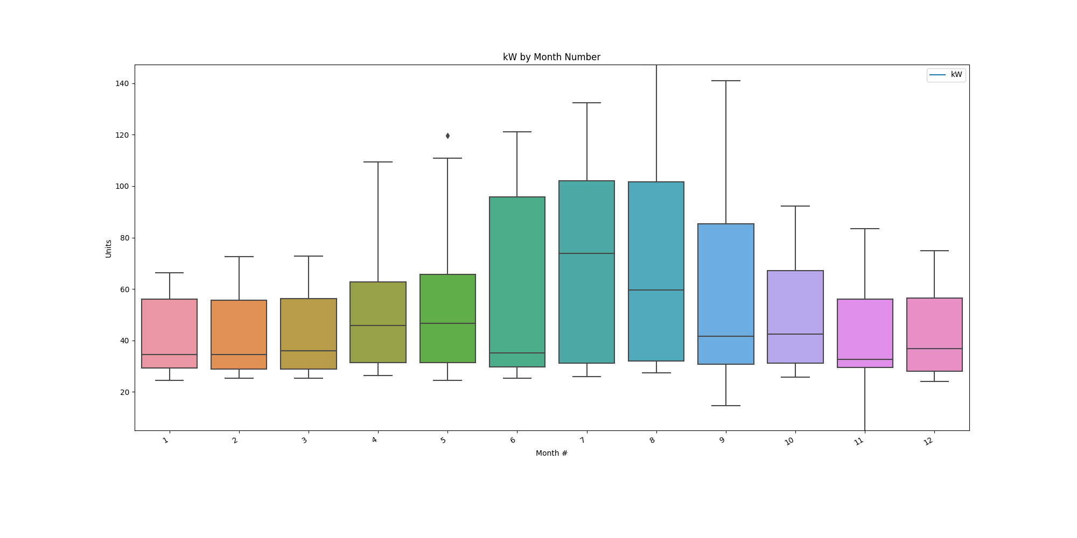

# Power consumption trends

kWtrendsPlot.png

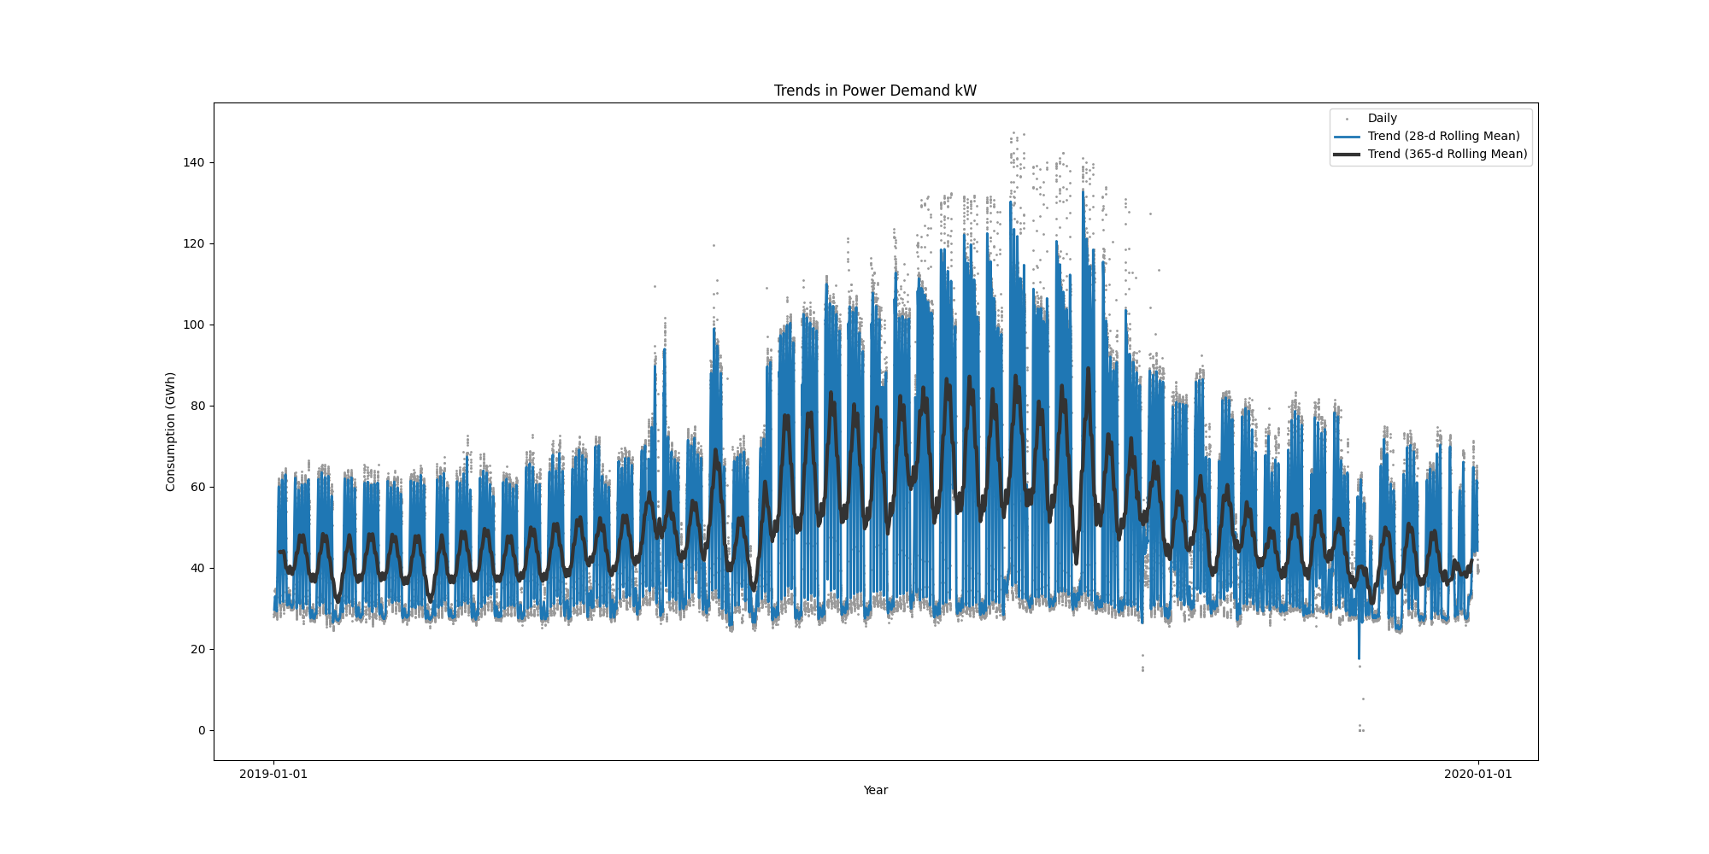

Data Analysis Report Winter

Winter Months Electrical Load Profiles

datasetPlot.png

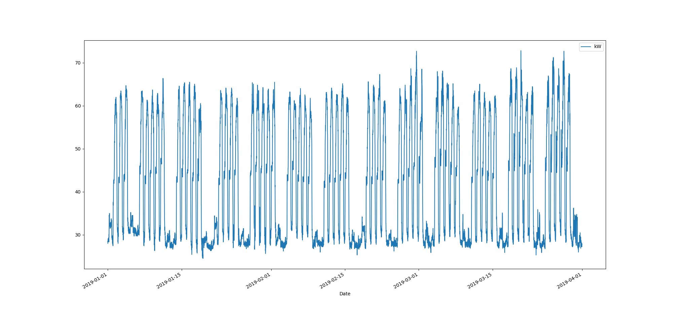

# Max Demand Found In Dataset

kW 72.787  
Name: 2019-03-20 09:30:00, dtype: float64

# Dataset Summary Statistics

kW  
count 8636.000000  
mean 41.558607  
std 13.649624  
min 24.525000  
25% 28.913000  
50% 35.100000  
75% 56.025000  
max 72.787000

# Highest Ranked Change Point Algorithm Detection

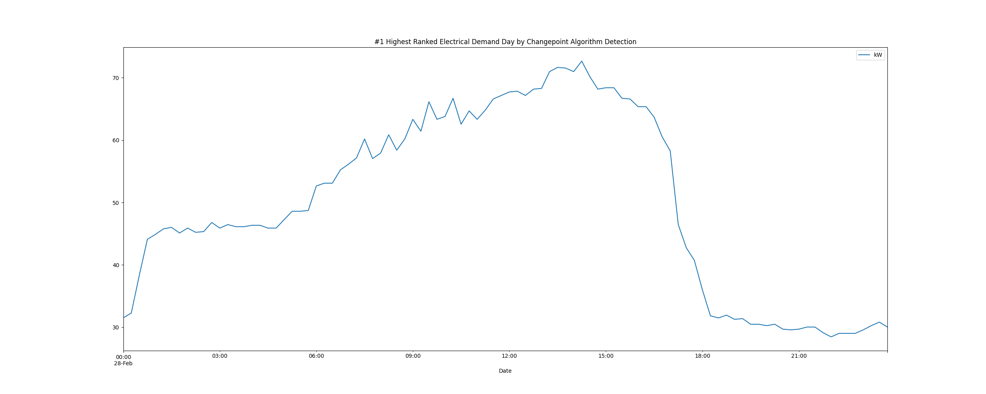

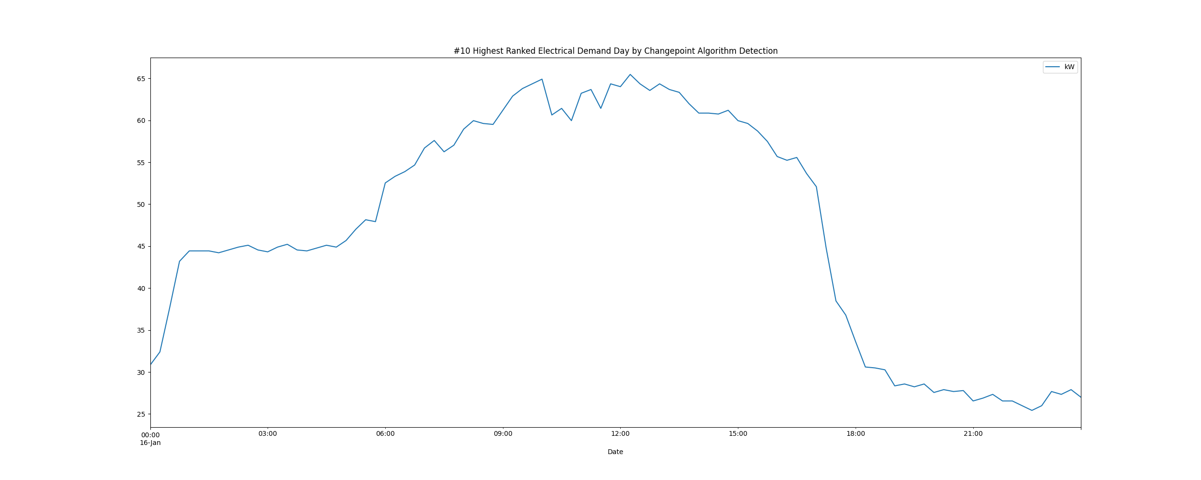

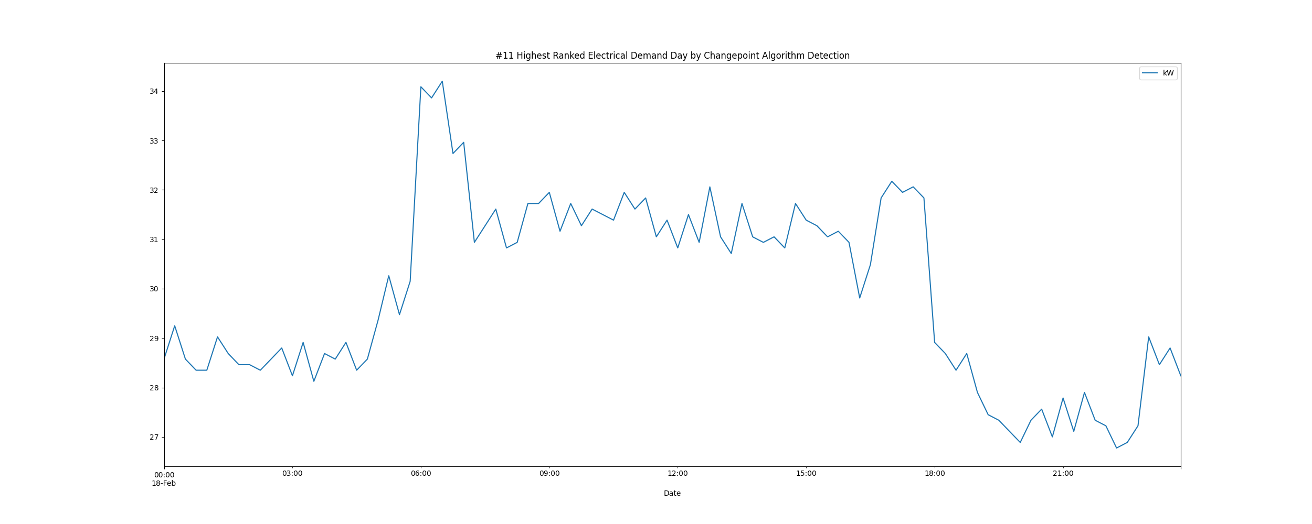

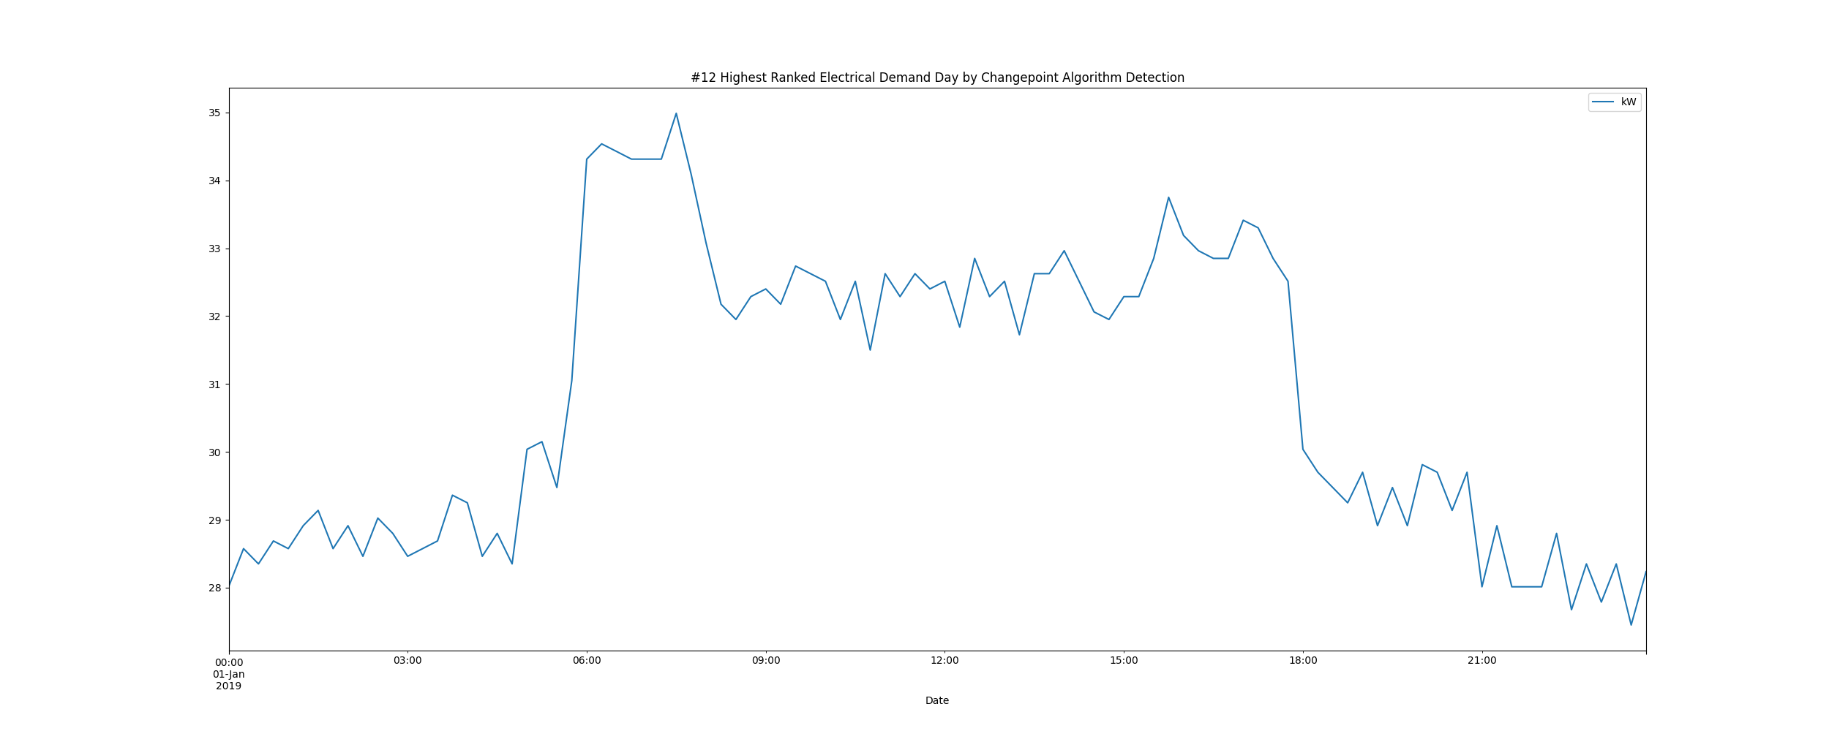

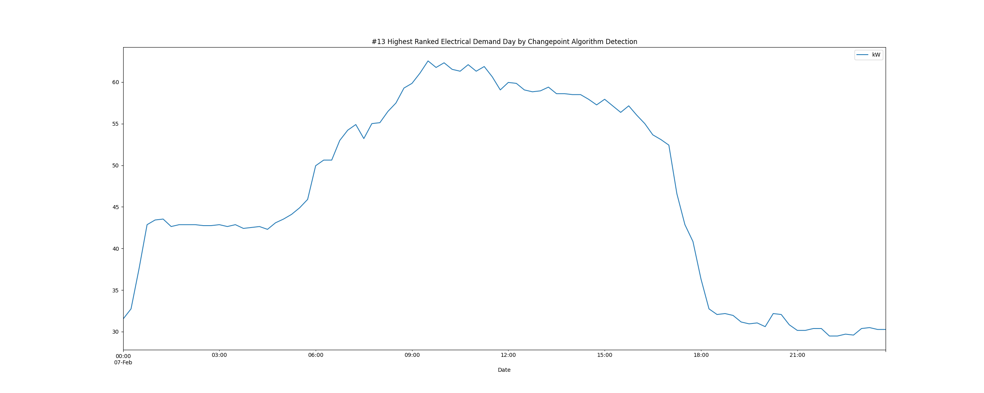

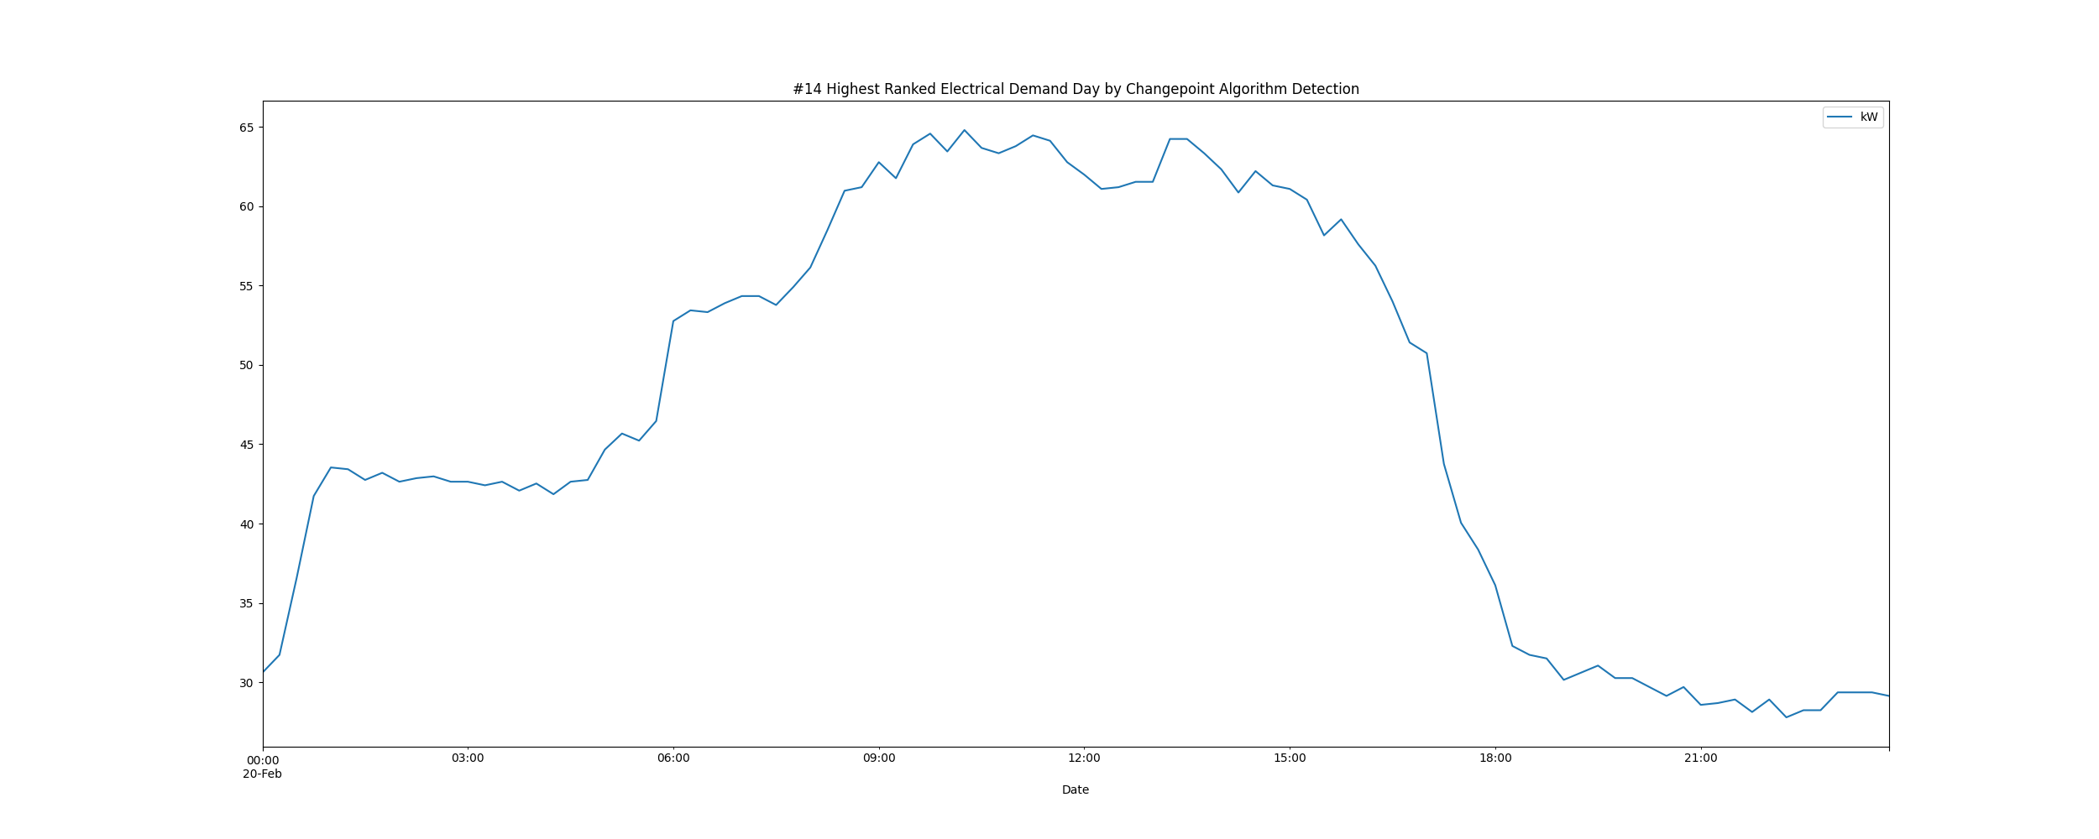

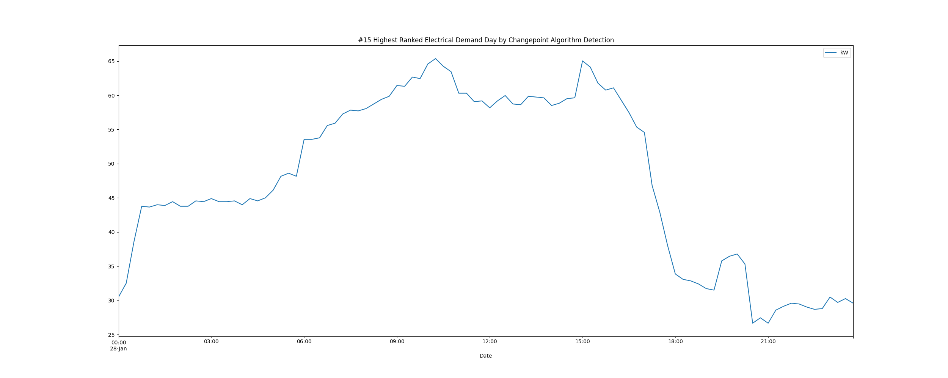

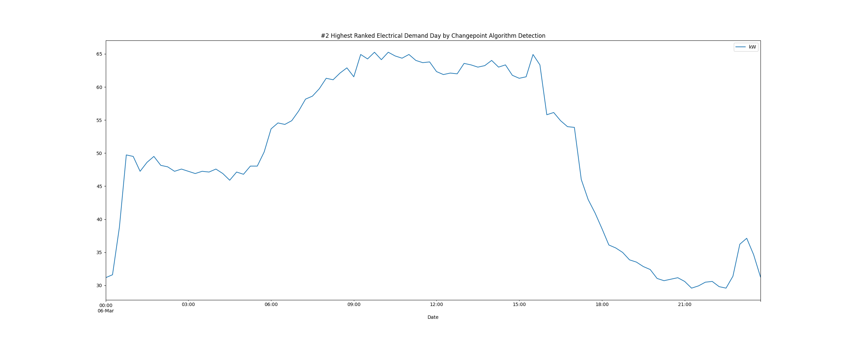

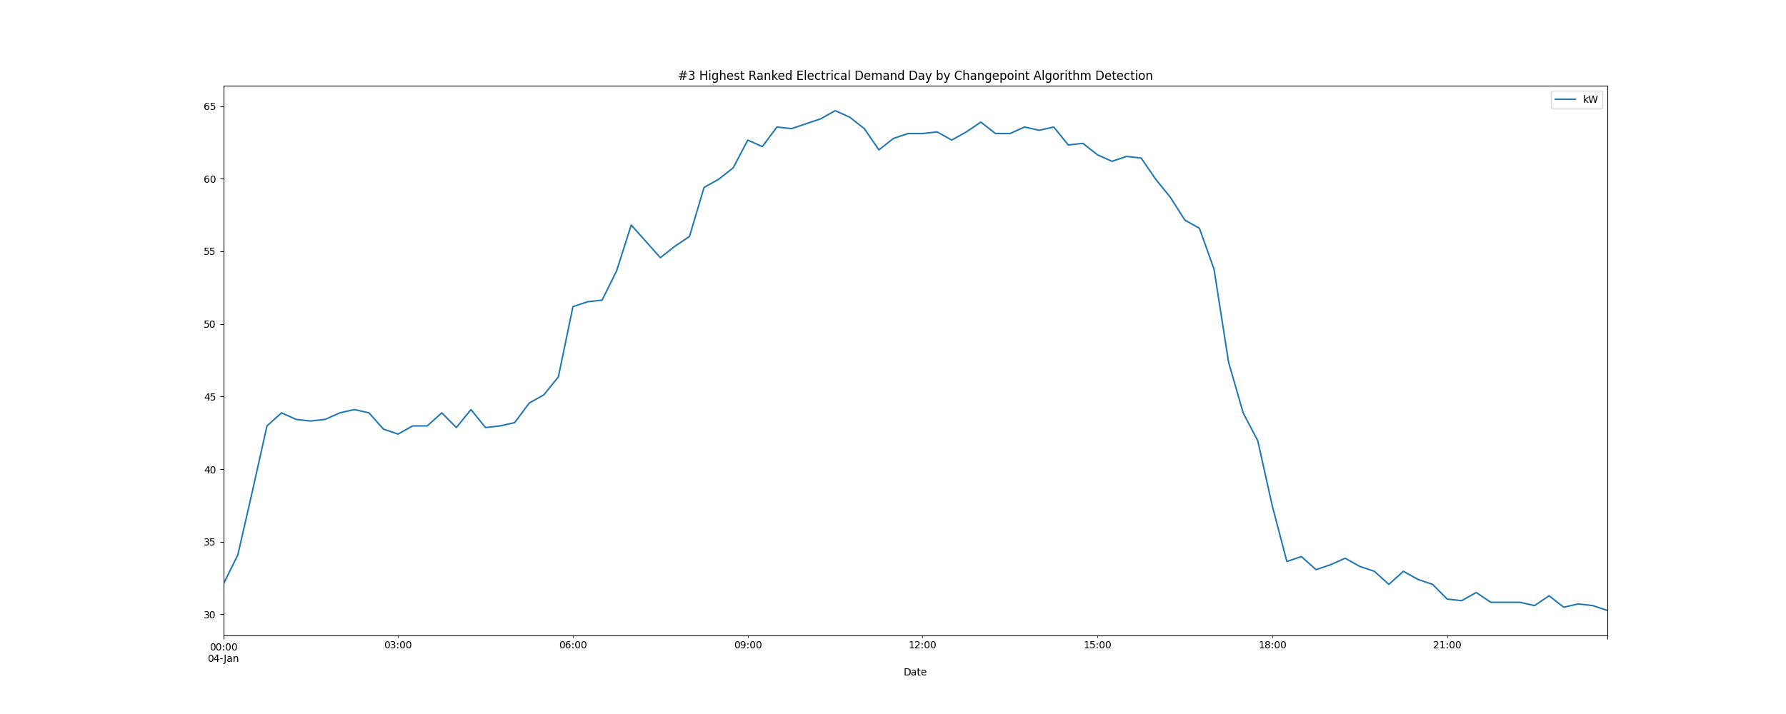

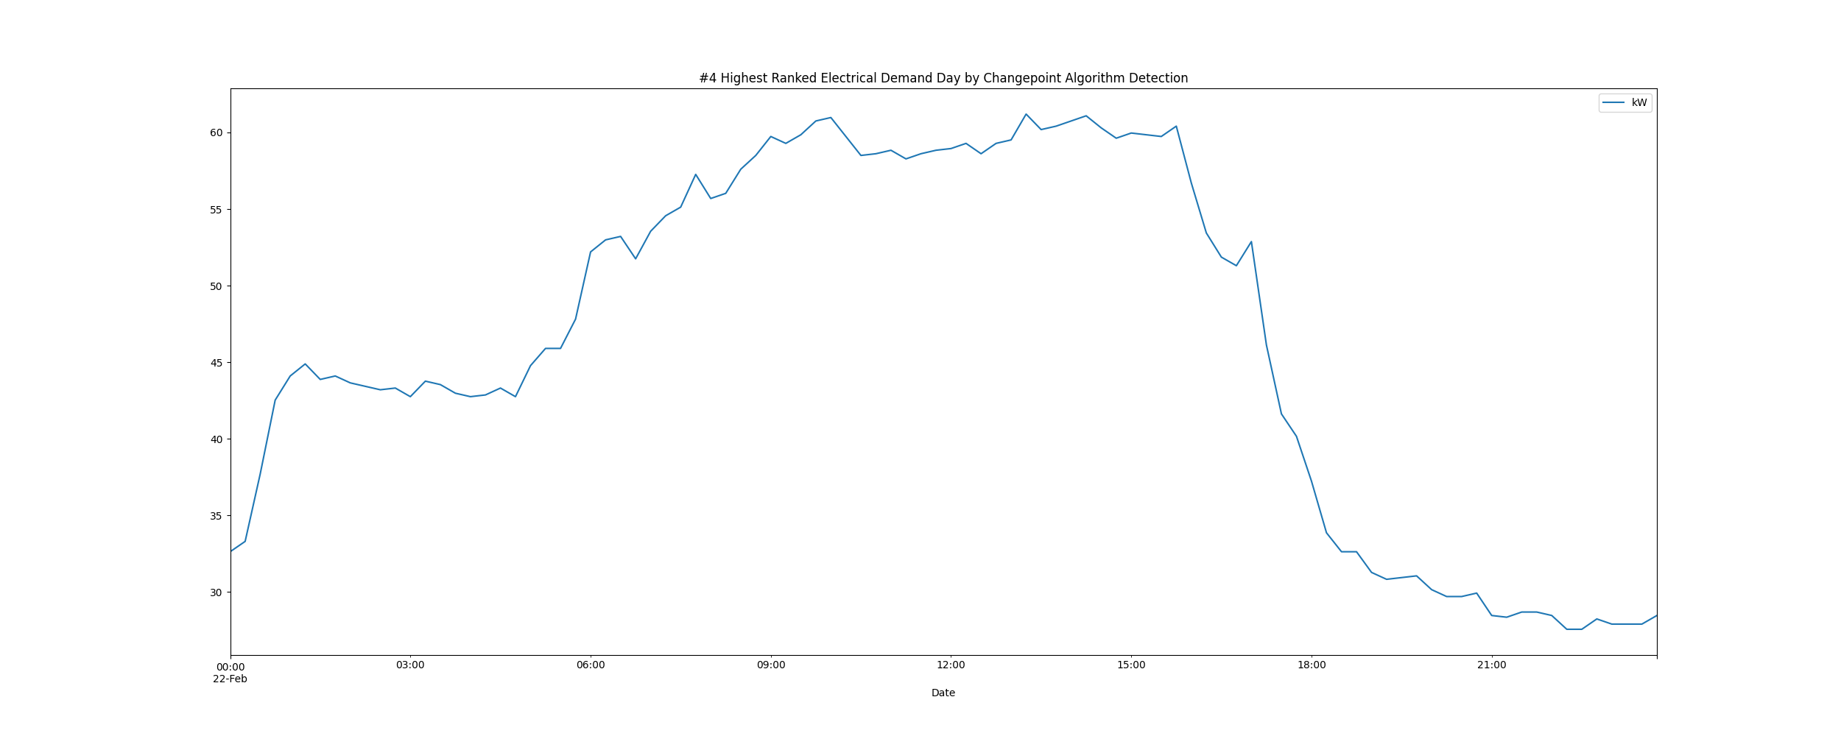

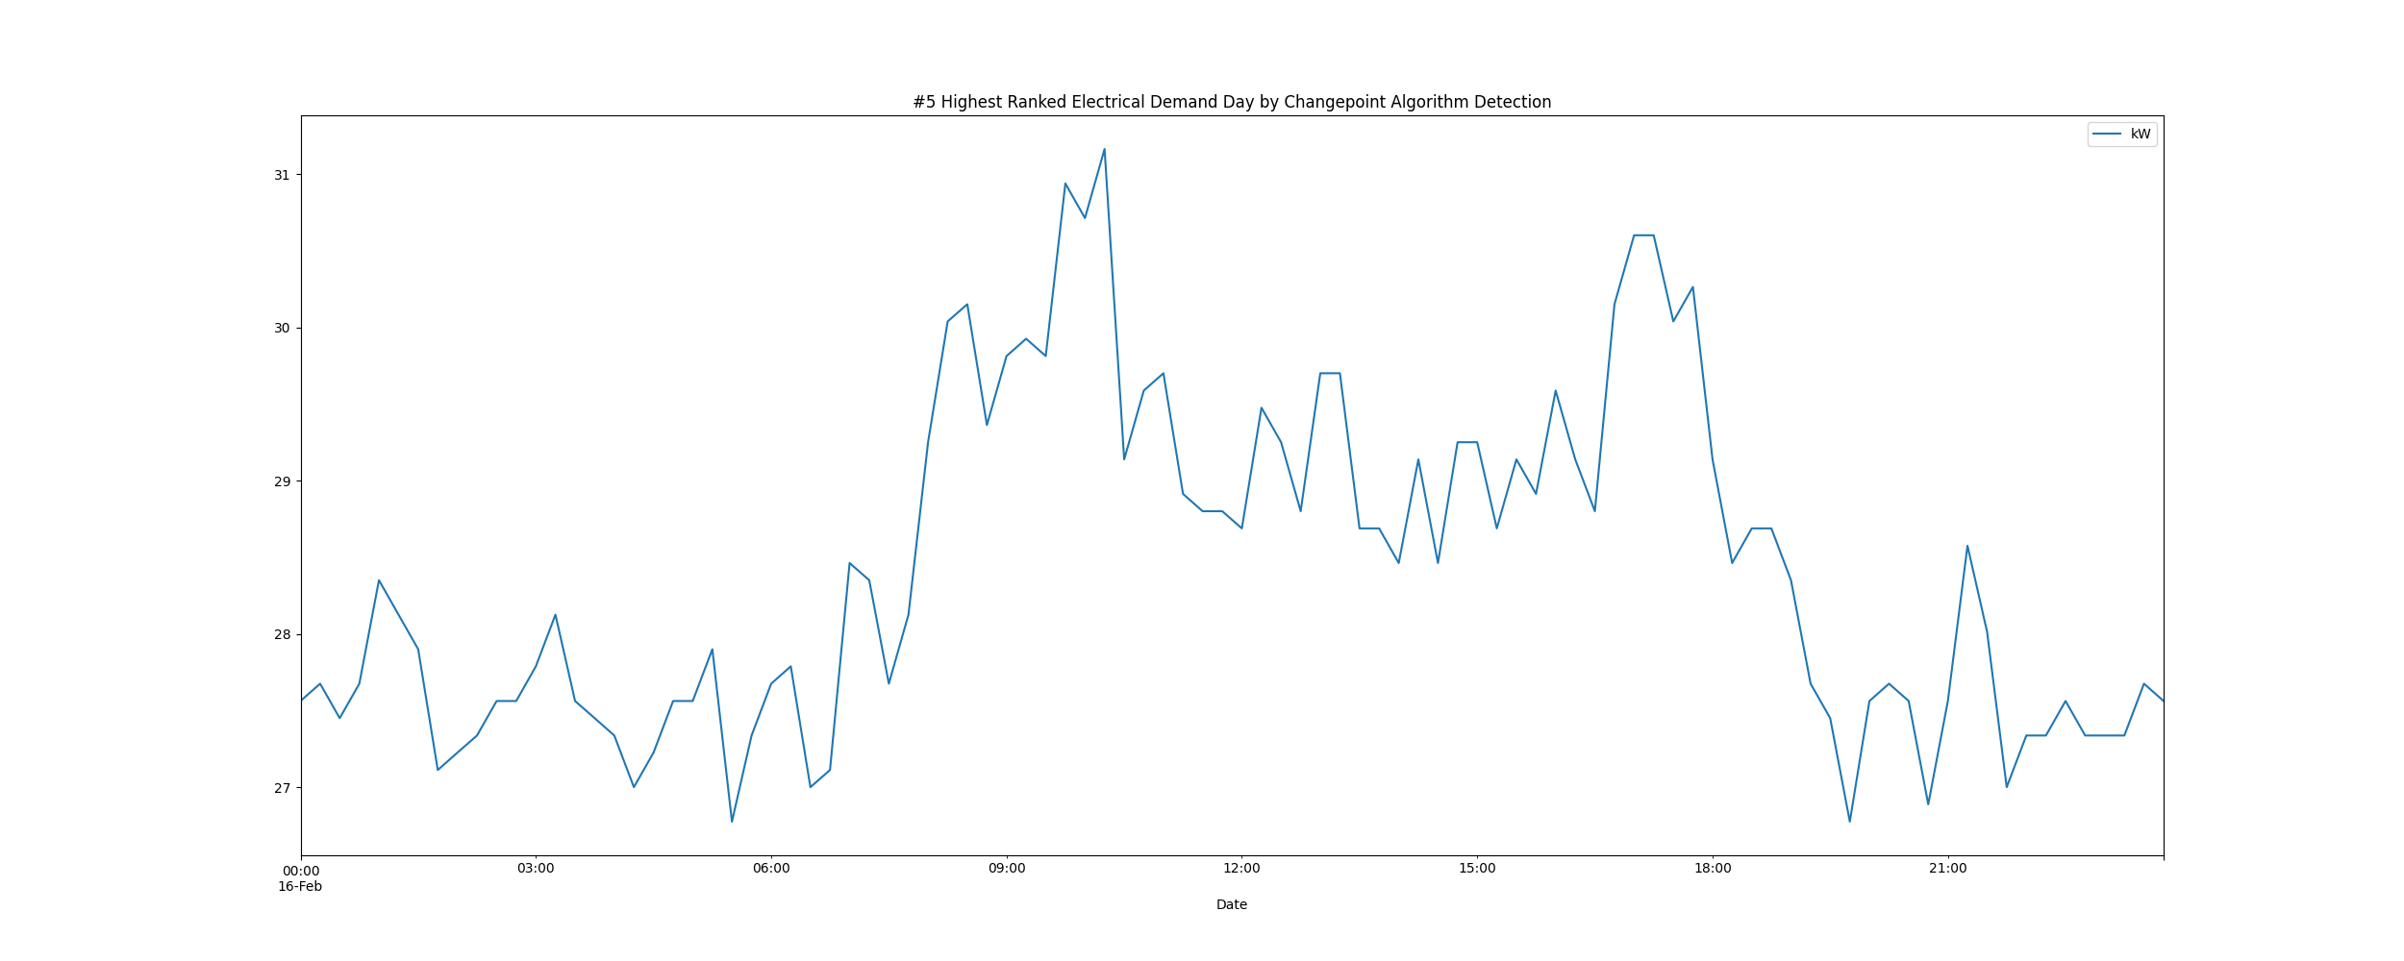

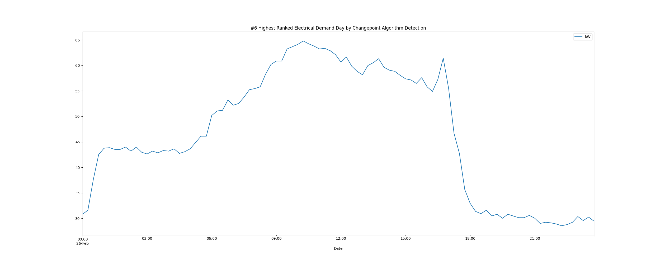

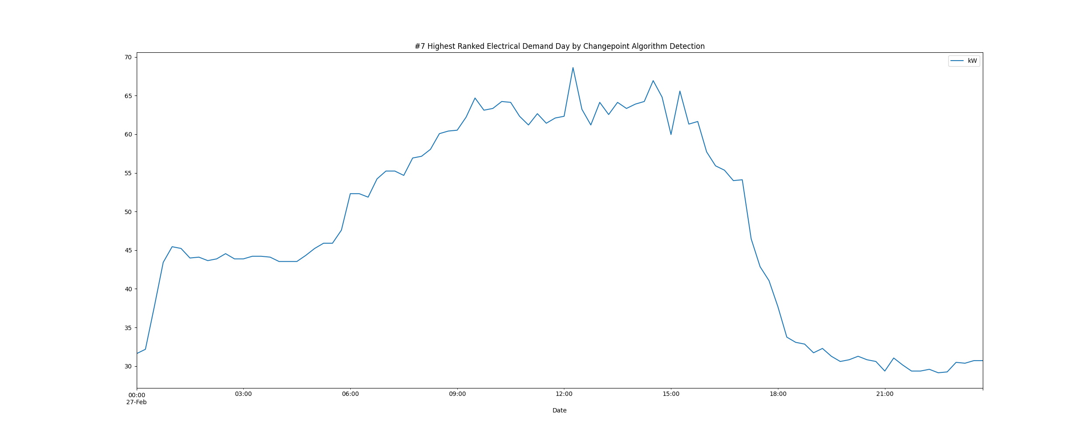

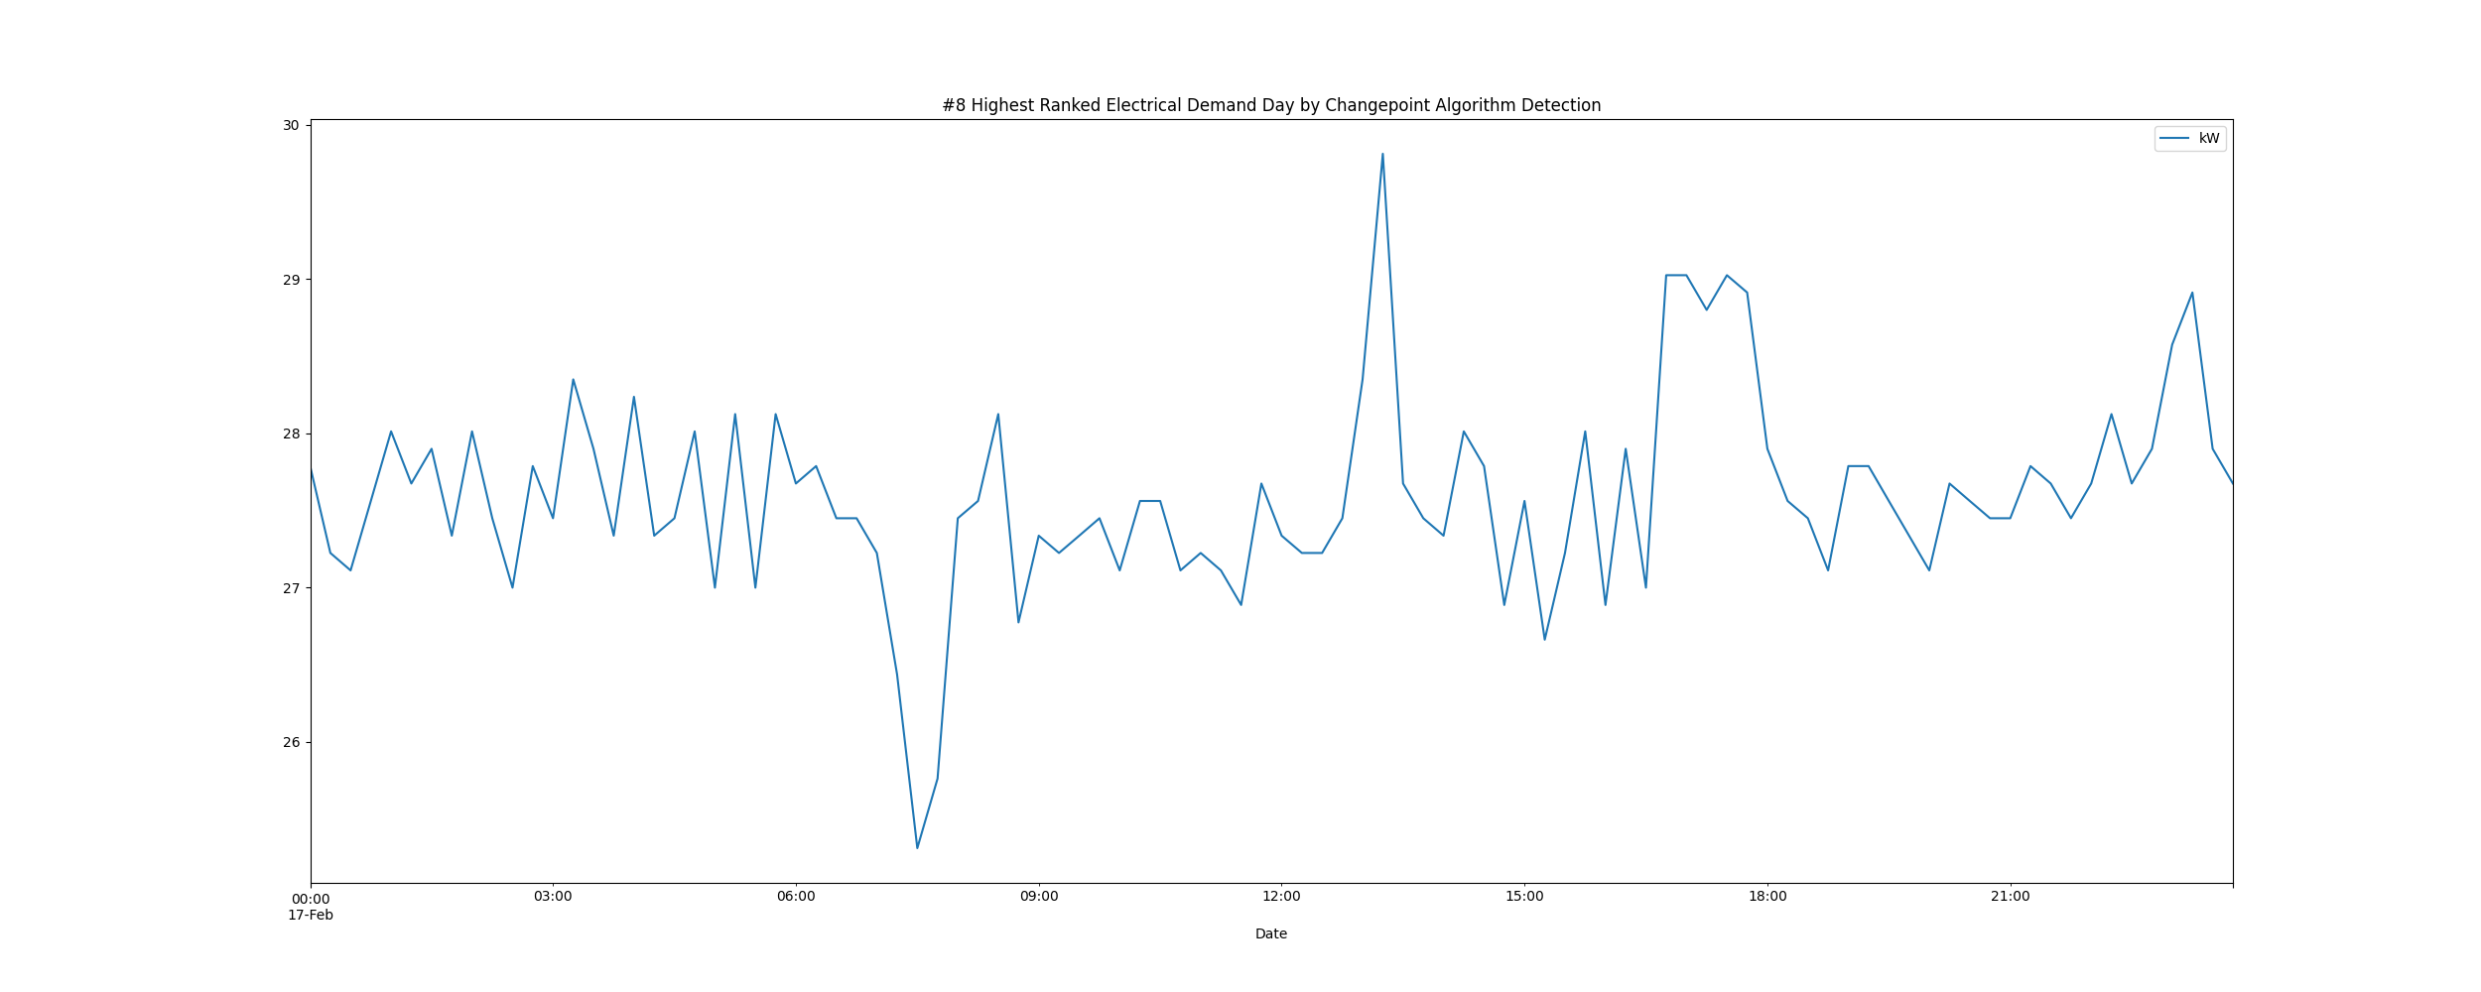

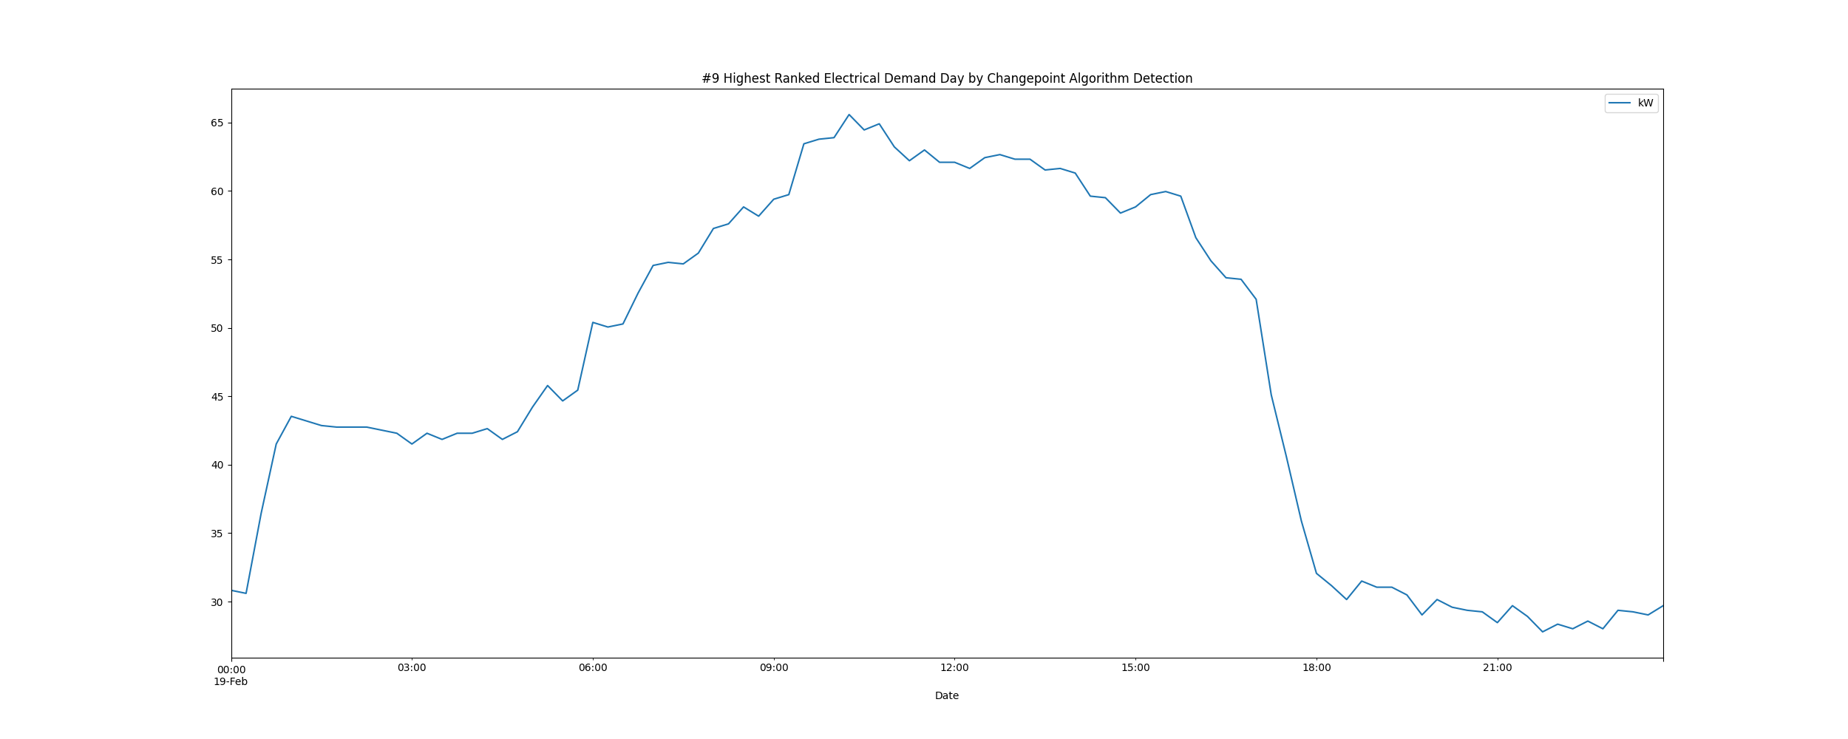

# Daily High and Low Load kW Values

highLowLoadsPlot.png

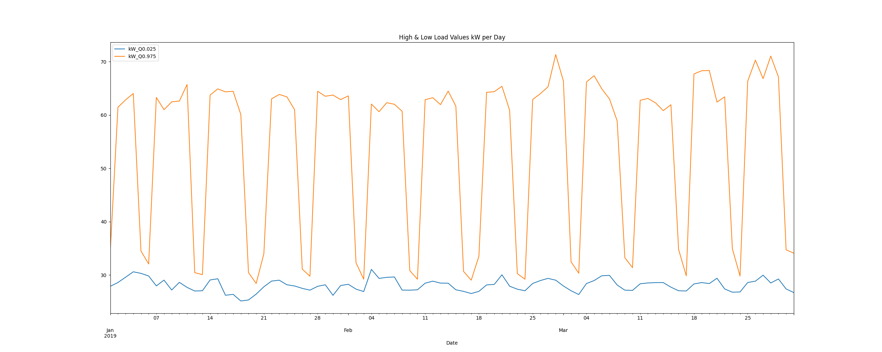

# Max Demand and Hour of Day Plot

Max_Demand_and_Max_Hour_of_Day.png

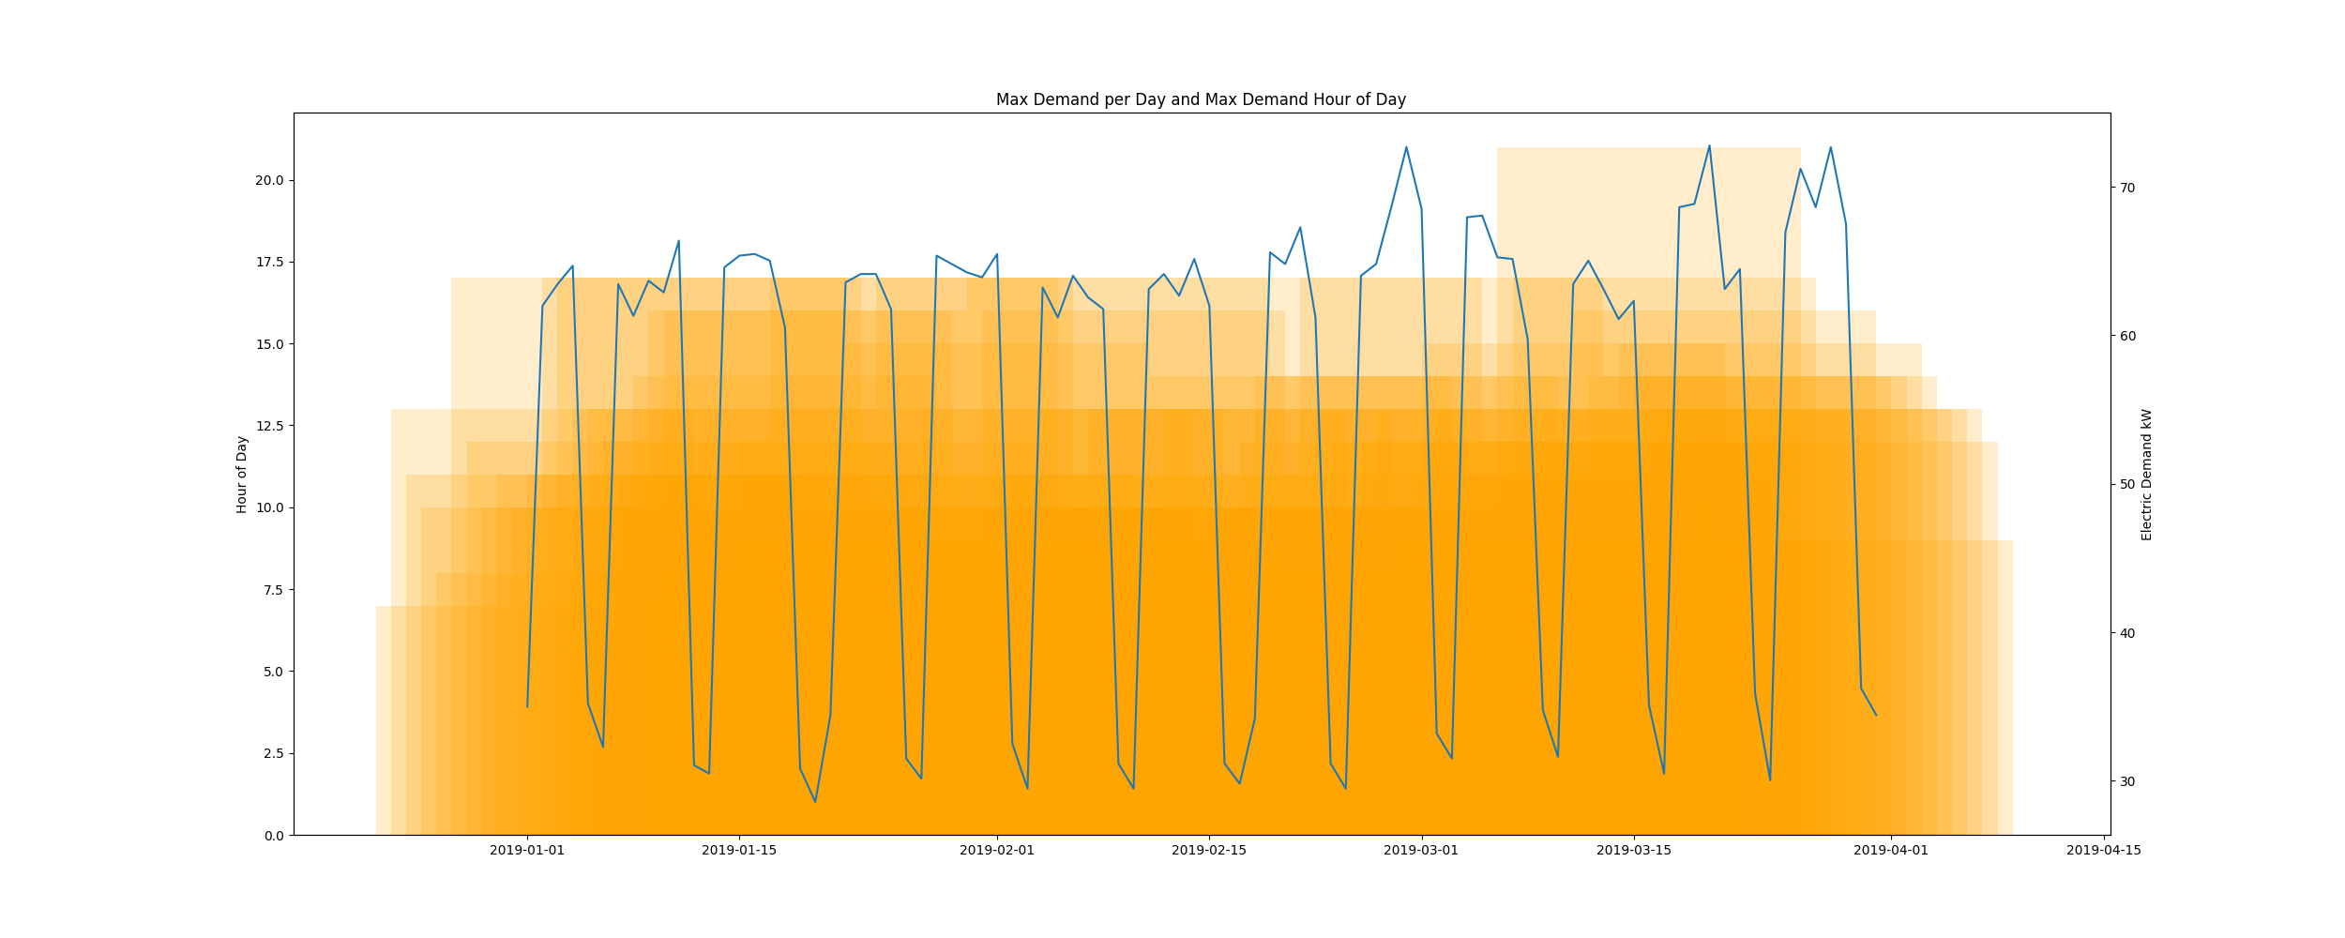

* Resampling the interval dataset to calculate units of energy KWh/day, the first day is 2019-01-01 and the last day is 2019-03-31
* Total days in dataset 89 days
* Total Sum of calculated electrical energy 89696.61124999999 kWh

# kWh Rolling 7 Day Avg

kWhRollingAvg.png

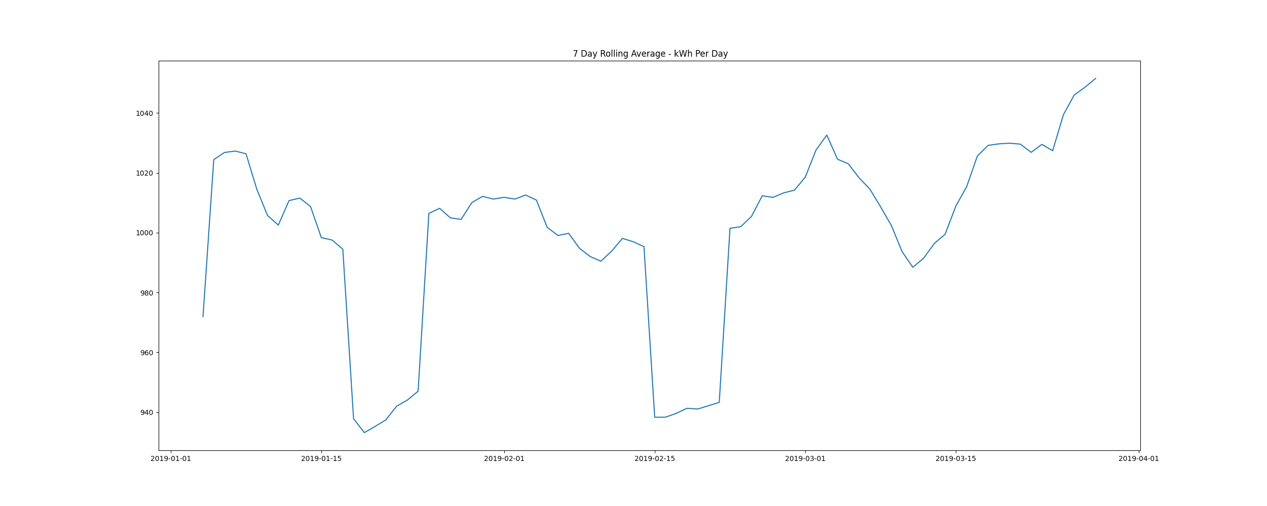

# Demand Plots By Month

Demands_for_Winter_Month_February.png

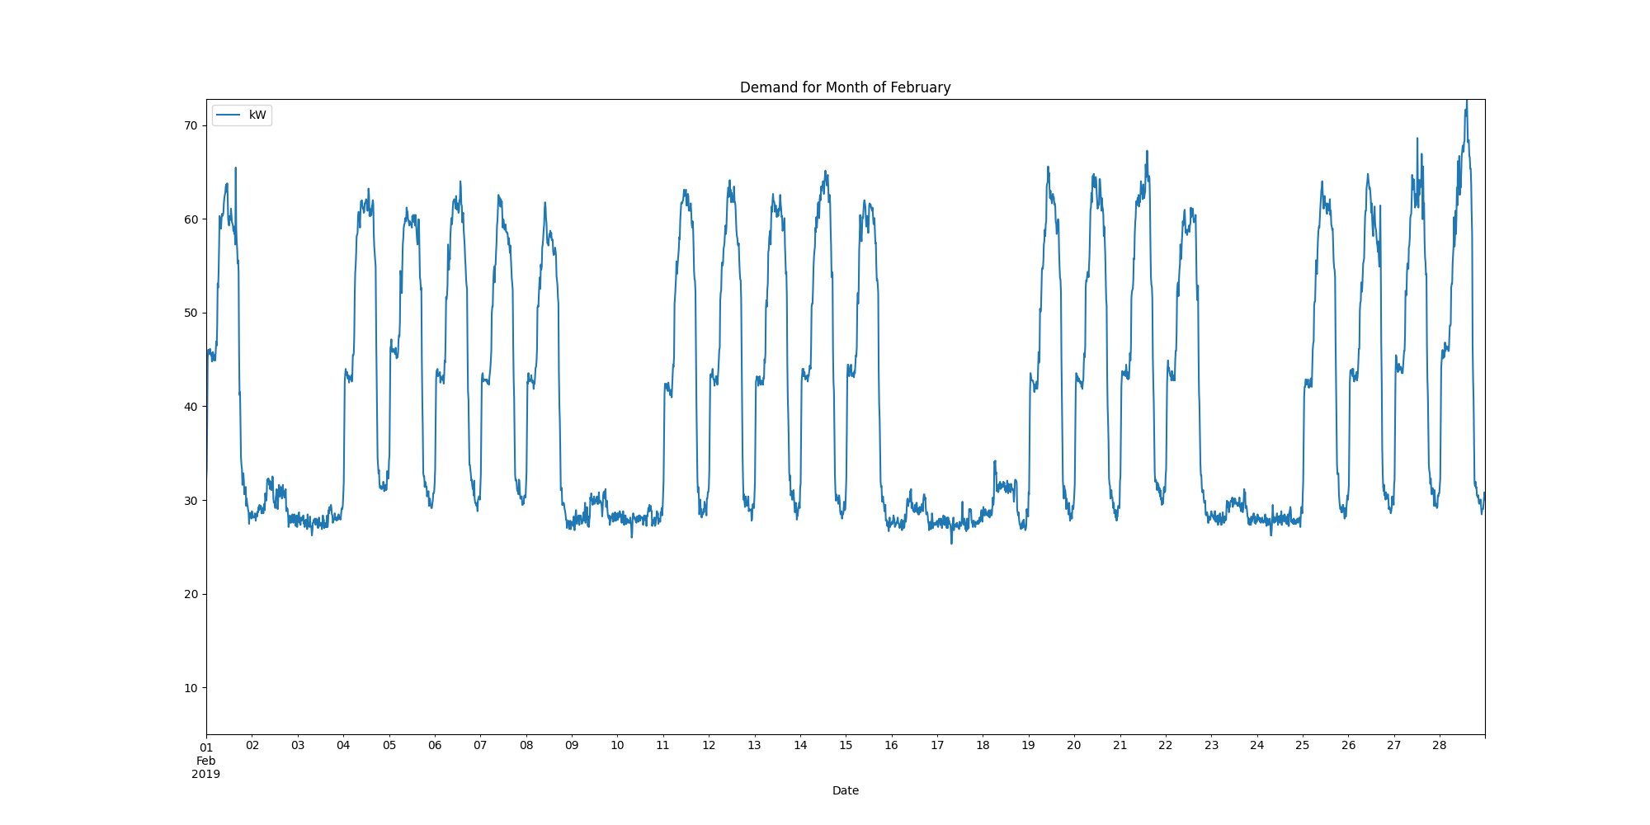

Demands_for_Winter_Month_January.png

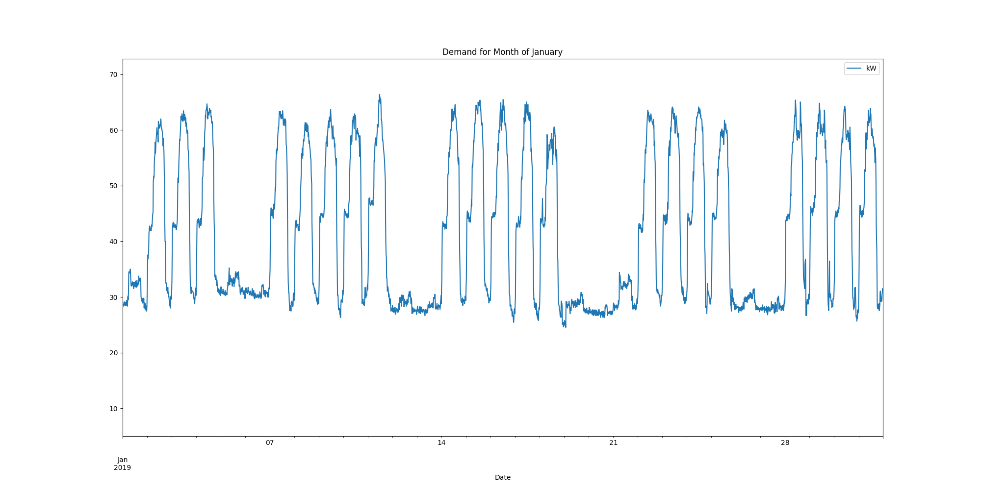

Demands_for_Winter_Month_March.png

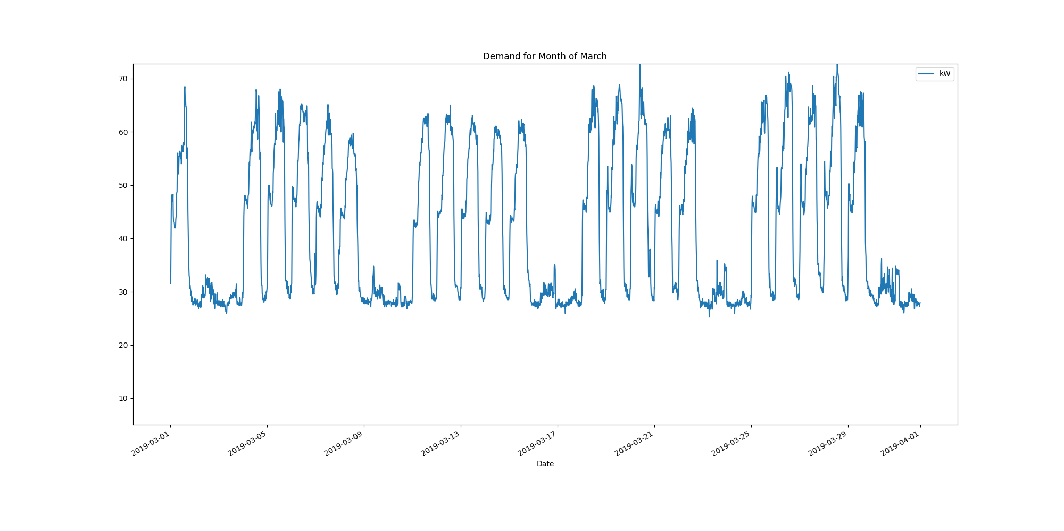

Data Analysis Report Summer

Summer Months Electrical Load Profiles

datasetPlot.png

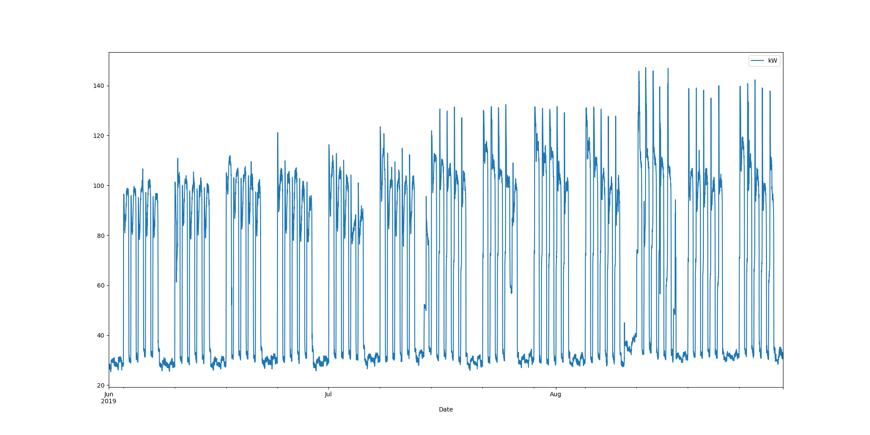

# Max Demand Found In Dataset

kW 147.262  
Name: 2019-08-13 06:00:00, dtype: float64

# Dataset Summary Statistics

kW  
count 8832.000000  
mean 65.356897  
std 34.863903  
min 25.312000  
25% 30.938000  
50% 64.350500  
75% 99.675000  
max 147.262000

# Highest Ranked Change Point Algorithm Detection

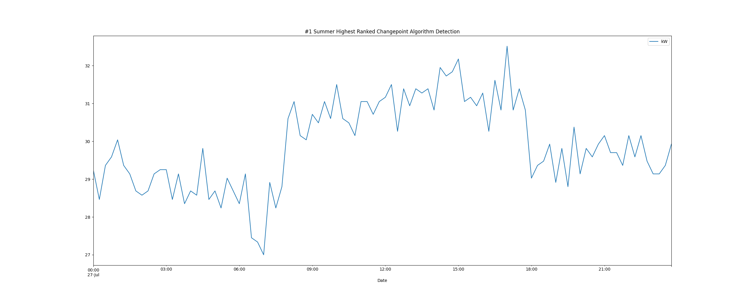

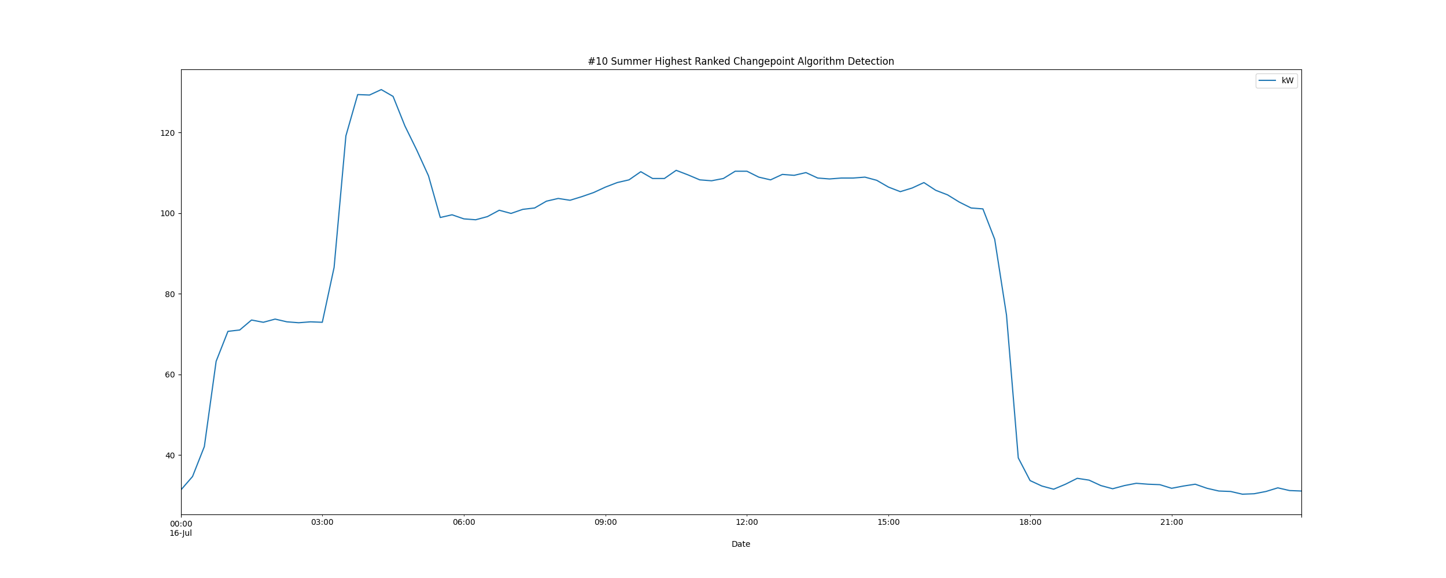

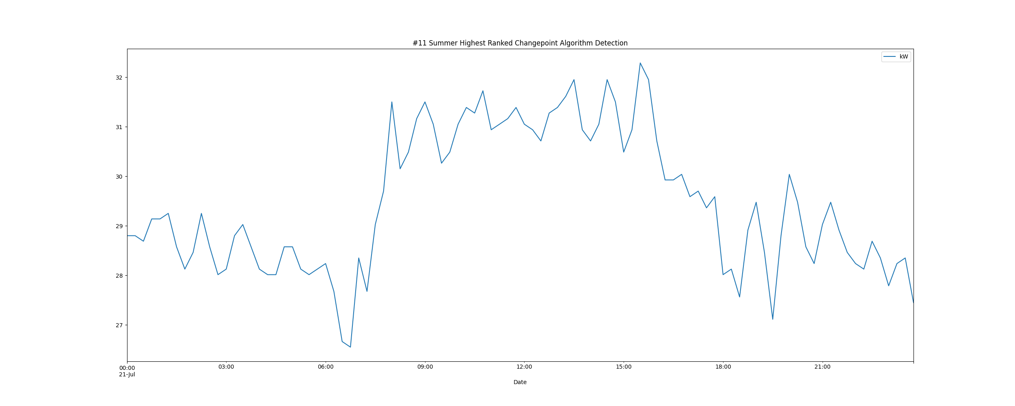

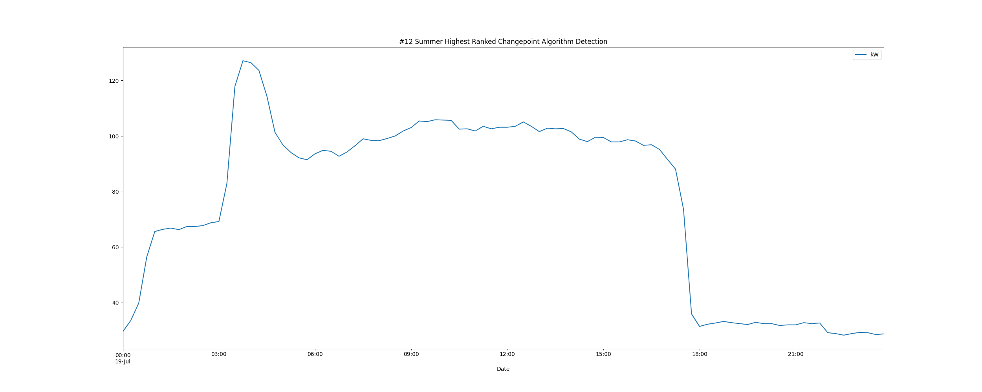

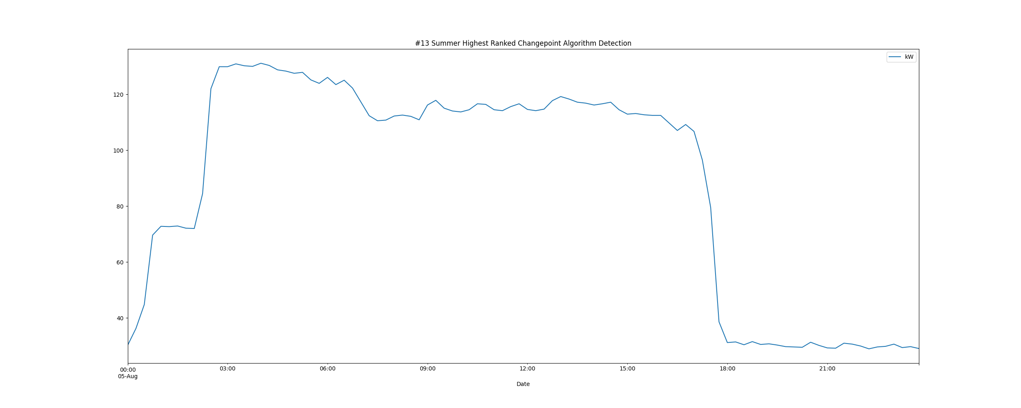

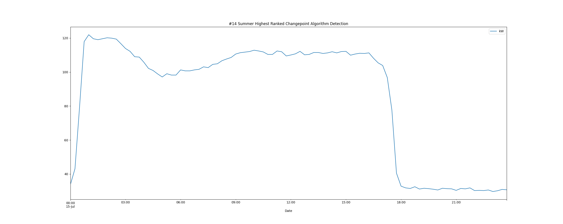

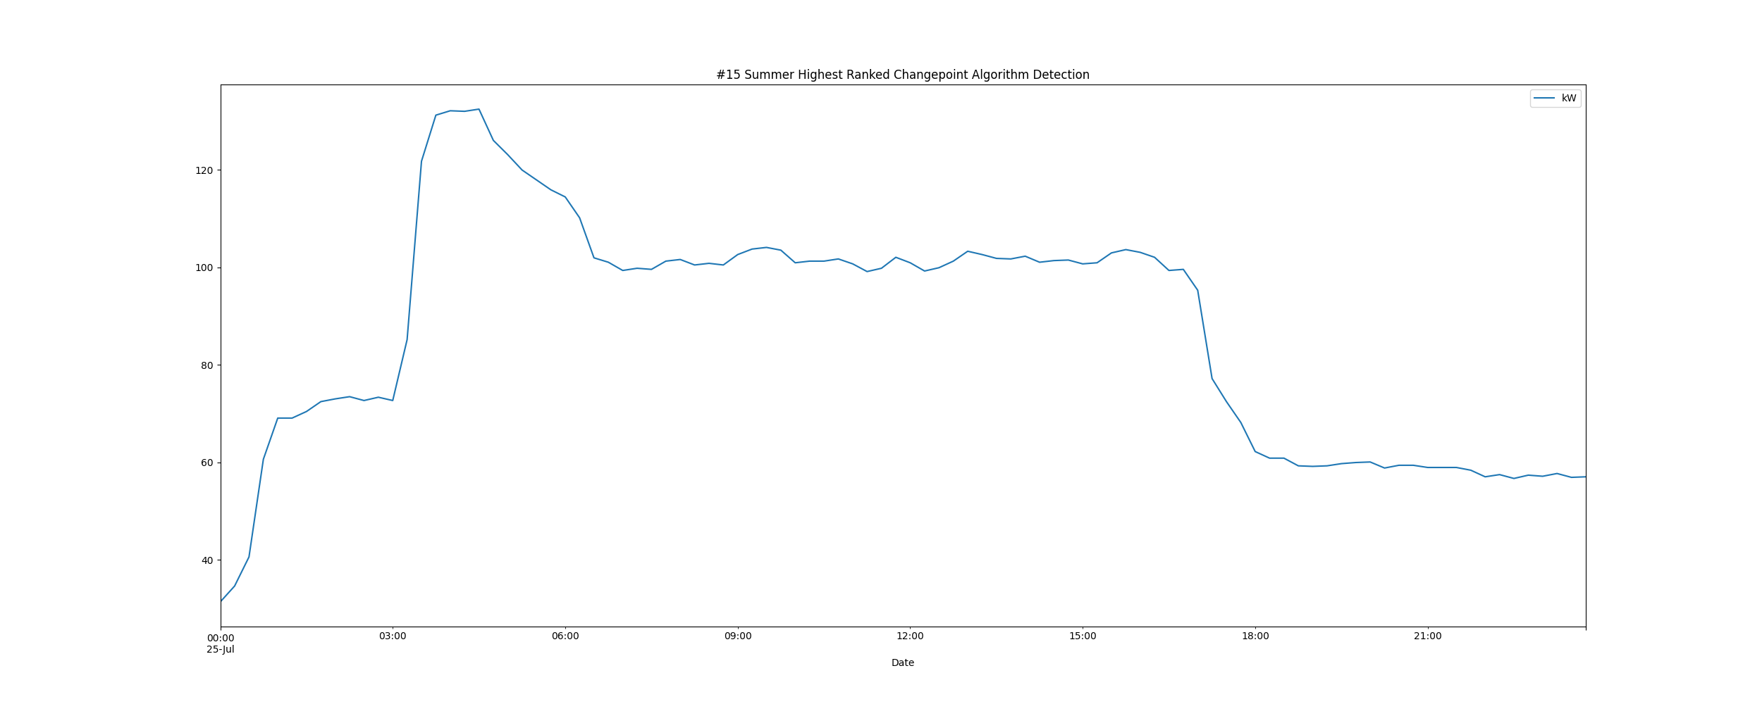

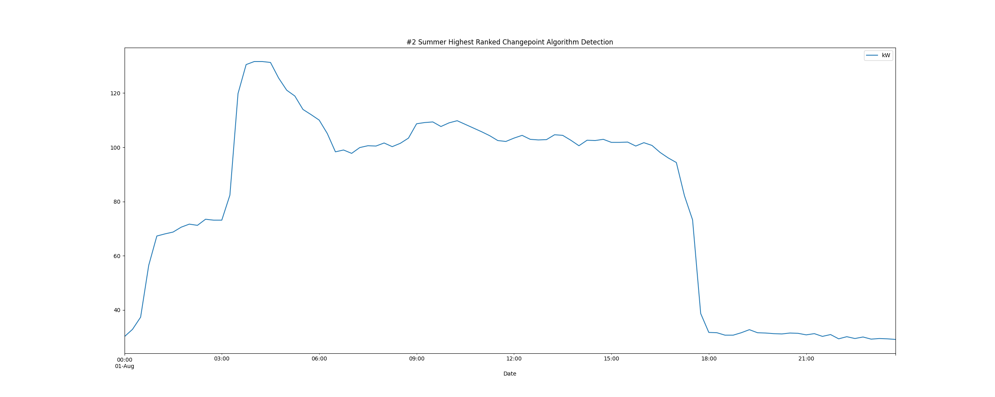

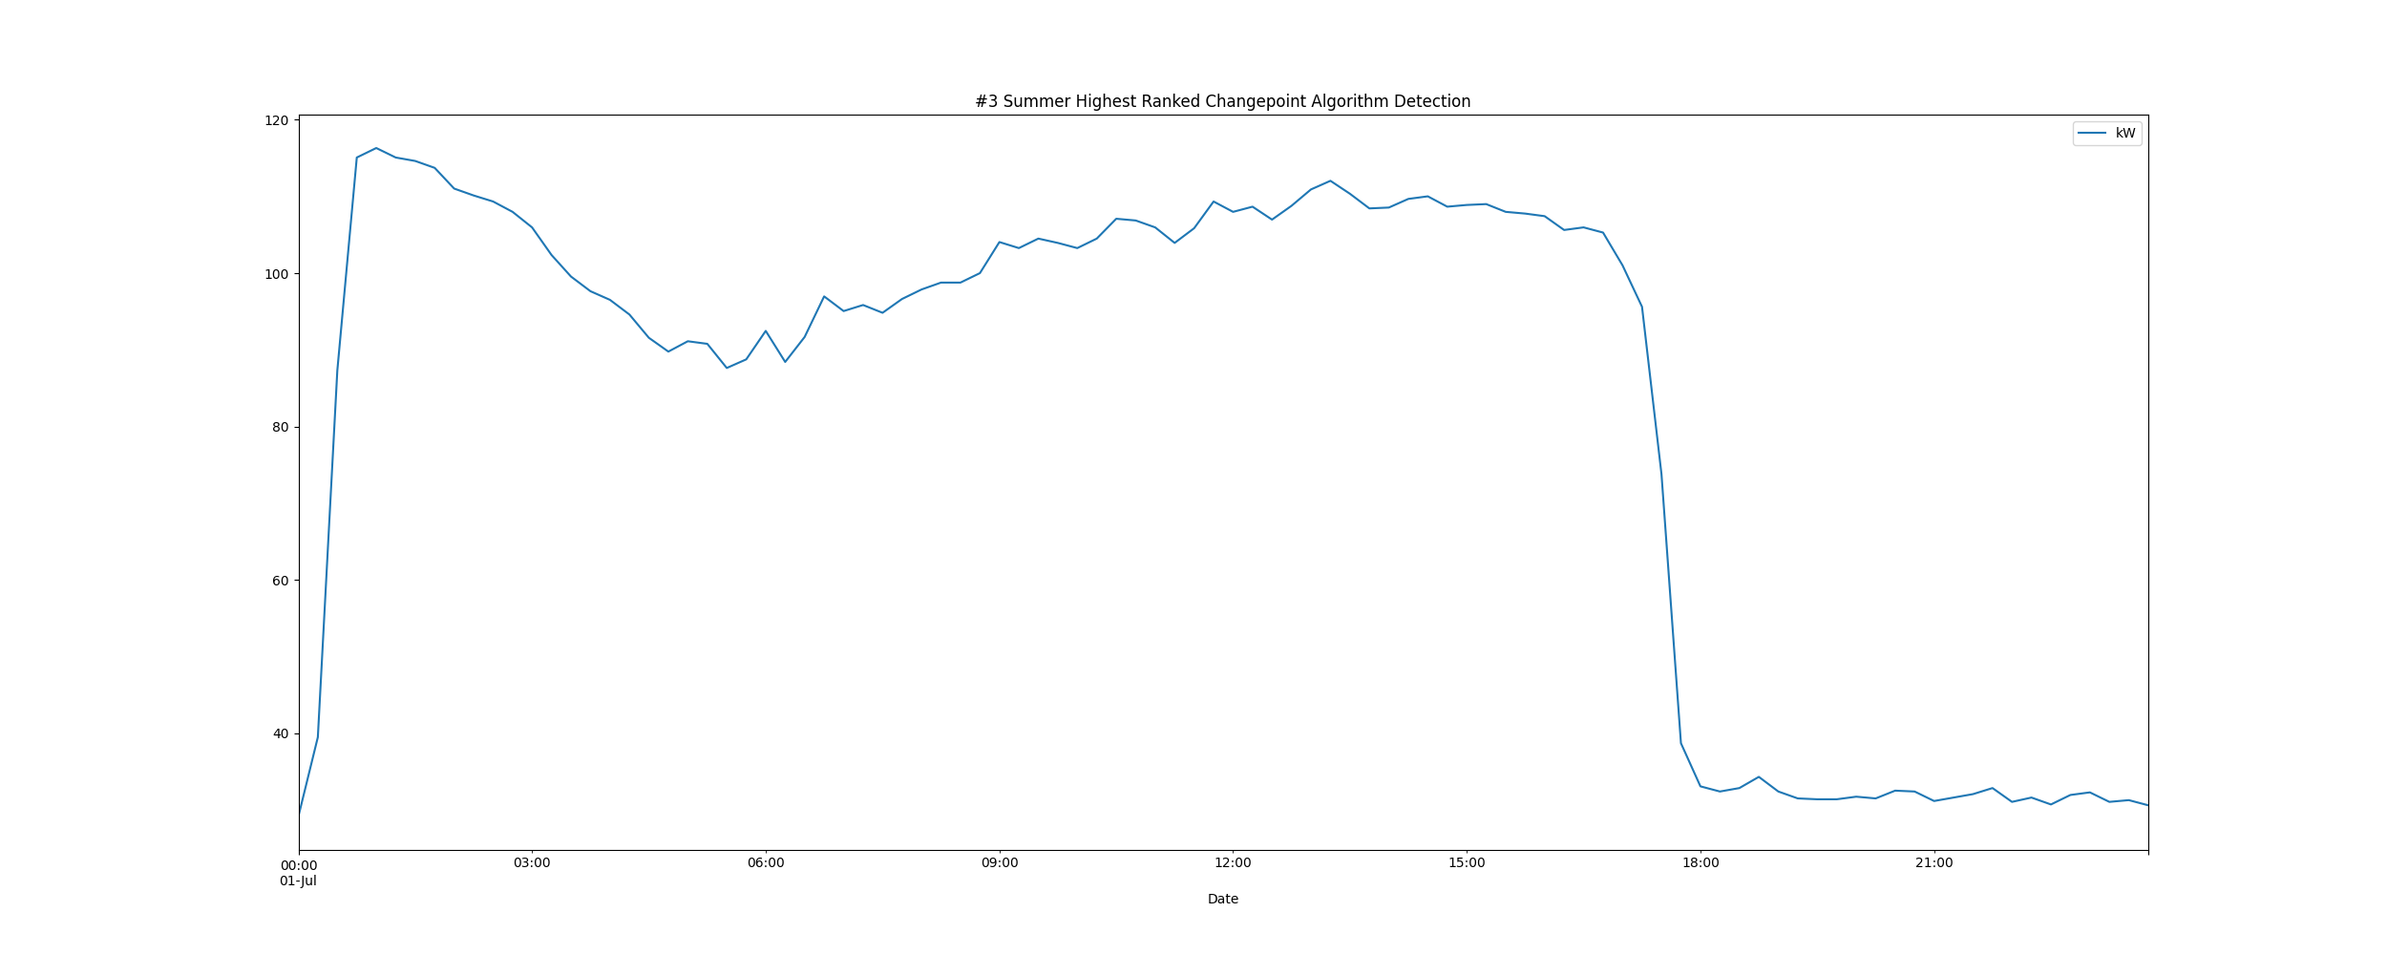

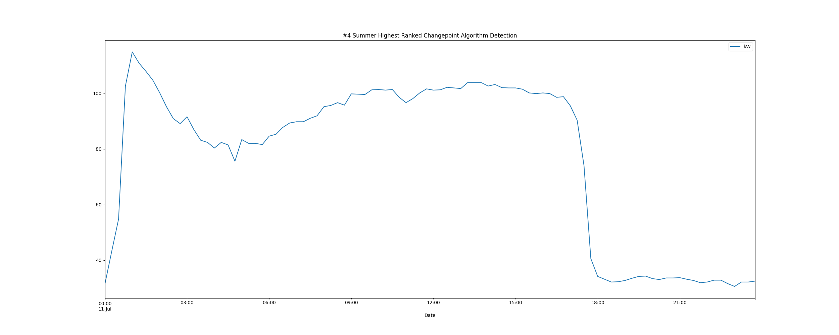

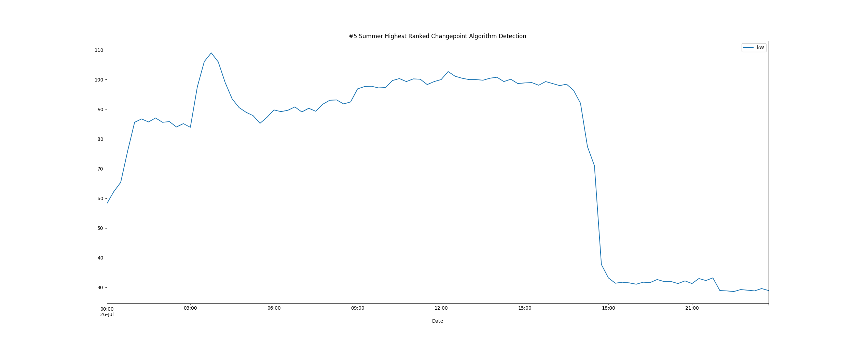

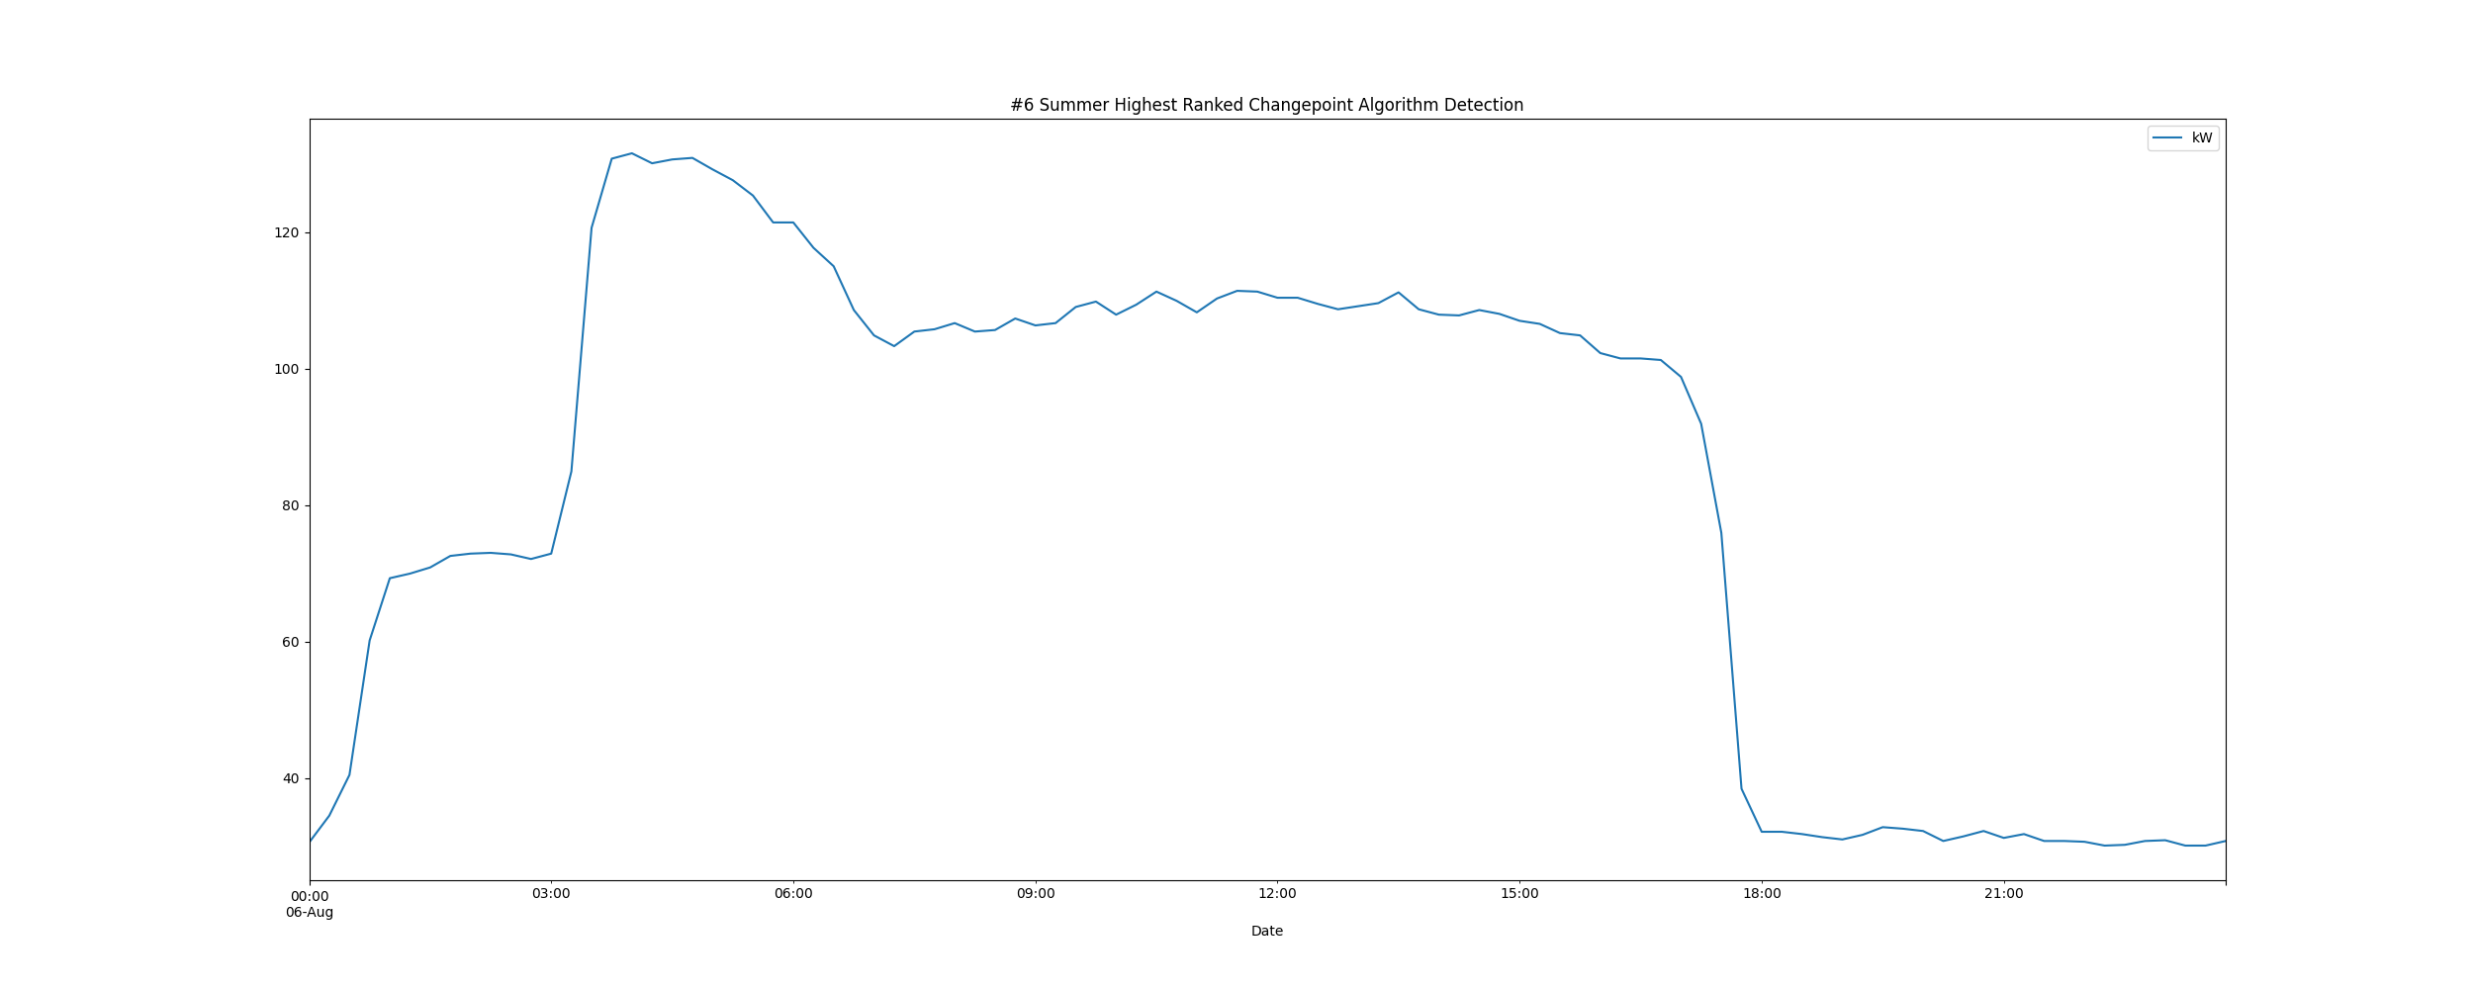

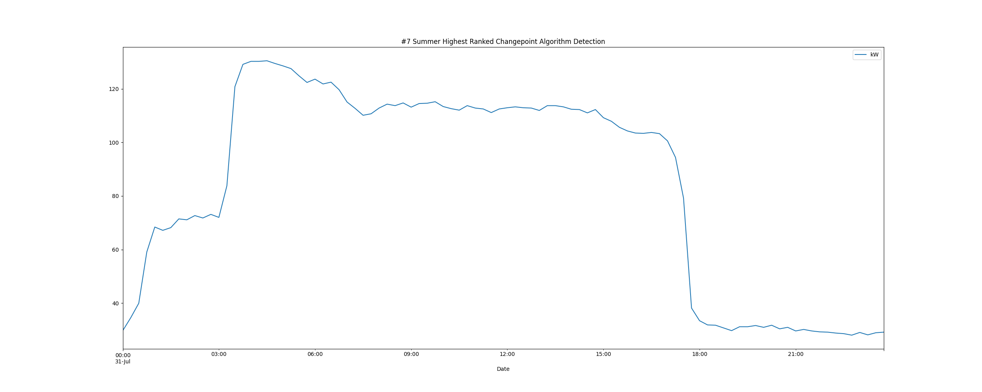

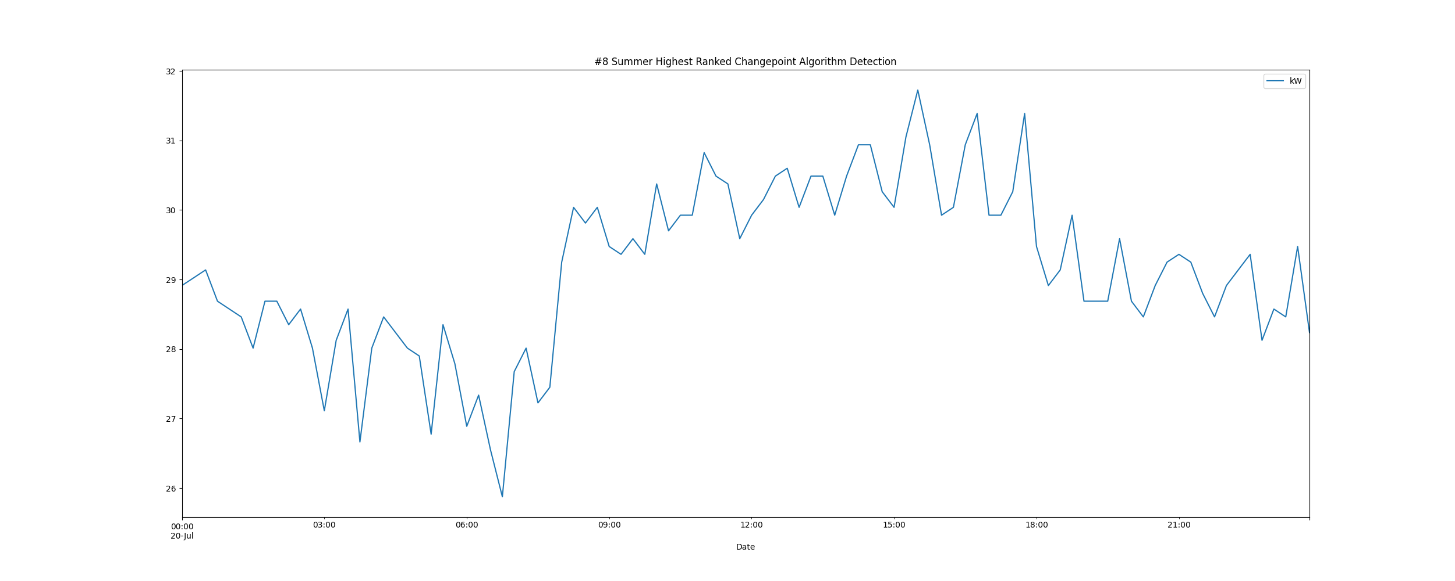

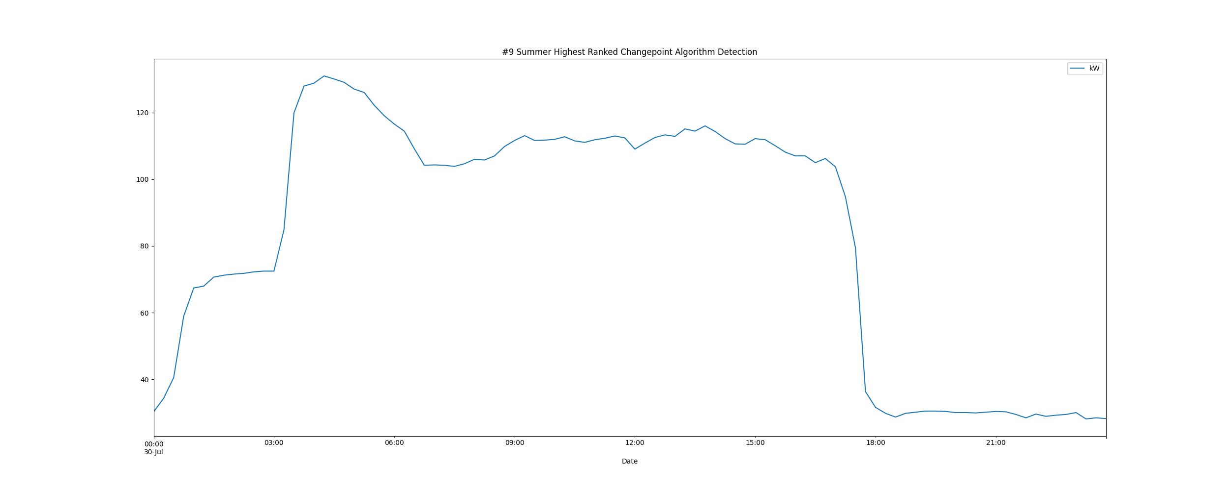

# Daily High and Low Load kW Values

highLowLoadsPlot.png

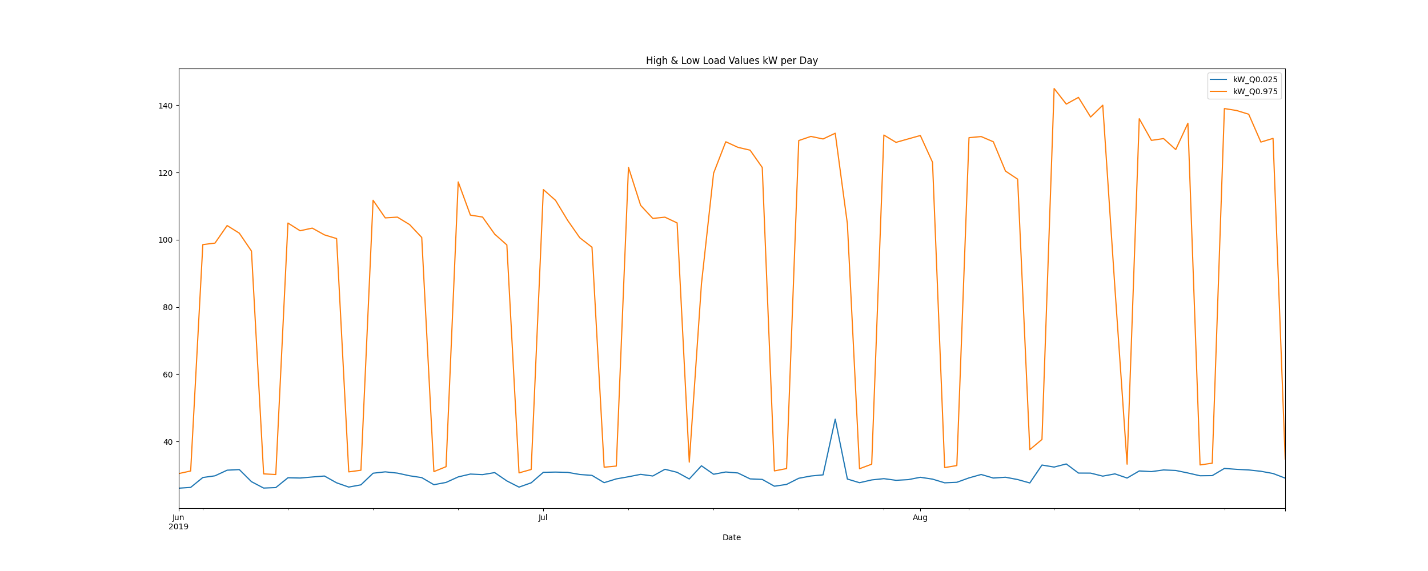

# Max Demand and Hour of Day Plot

Max_Demand_and_Max_Hour_of_Day.png

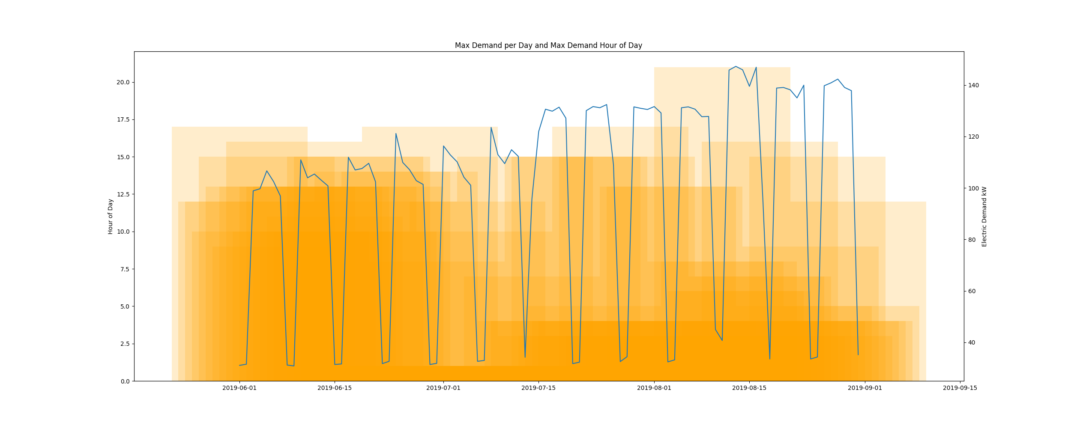

* Resampling the interval dataset to calculate units of energy KWh/day, the first day is 2019-06-01 and the last day is 2019-08-31
* Total days in dataset 91 days
* Total Sum of calculated electrical energy 144308.02800000002 kWh

# kWh Rolling 7 Day Avg

kWhRollingAvg.png

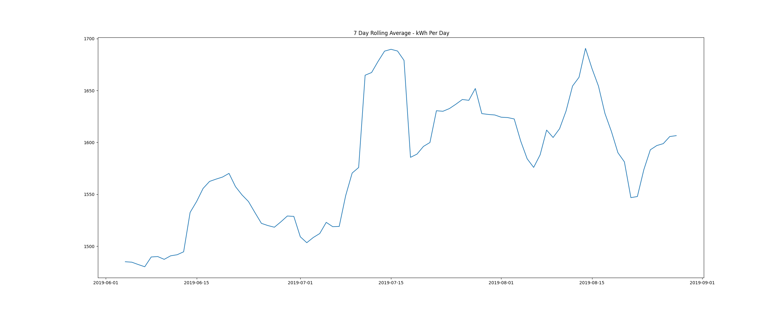

# Demand Plots By Month

Demands_for_Summer_Month_August.png

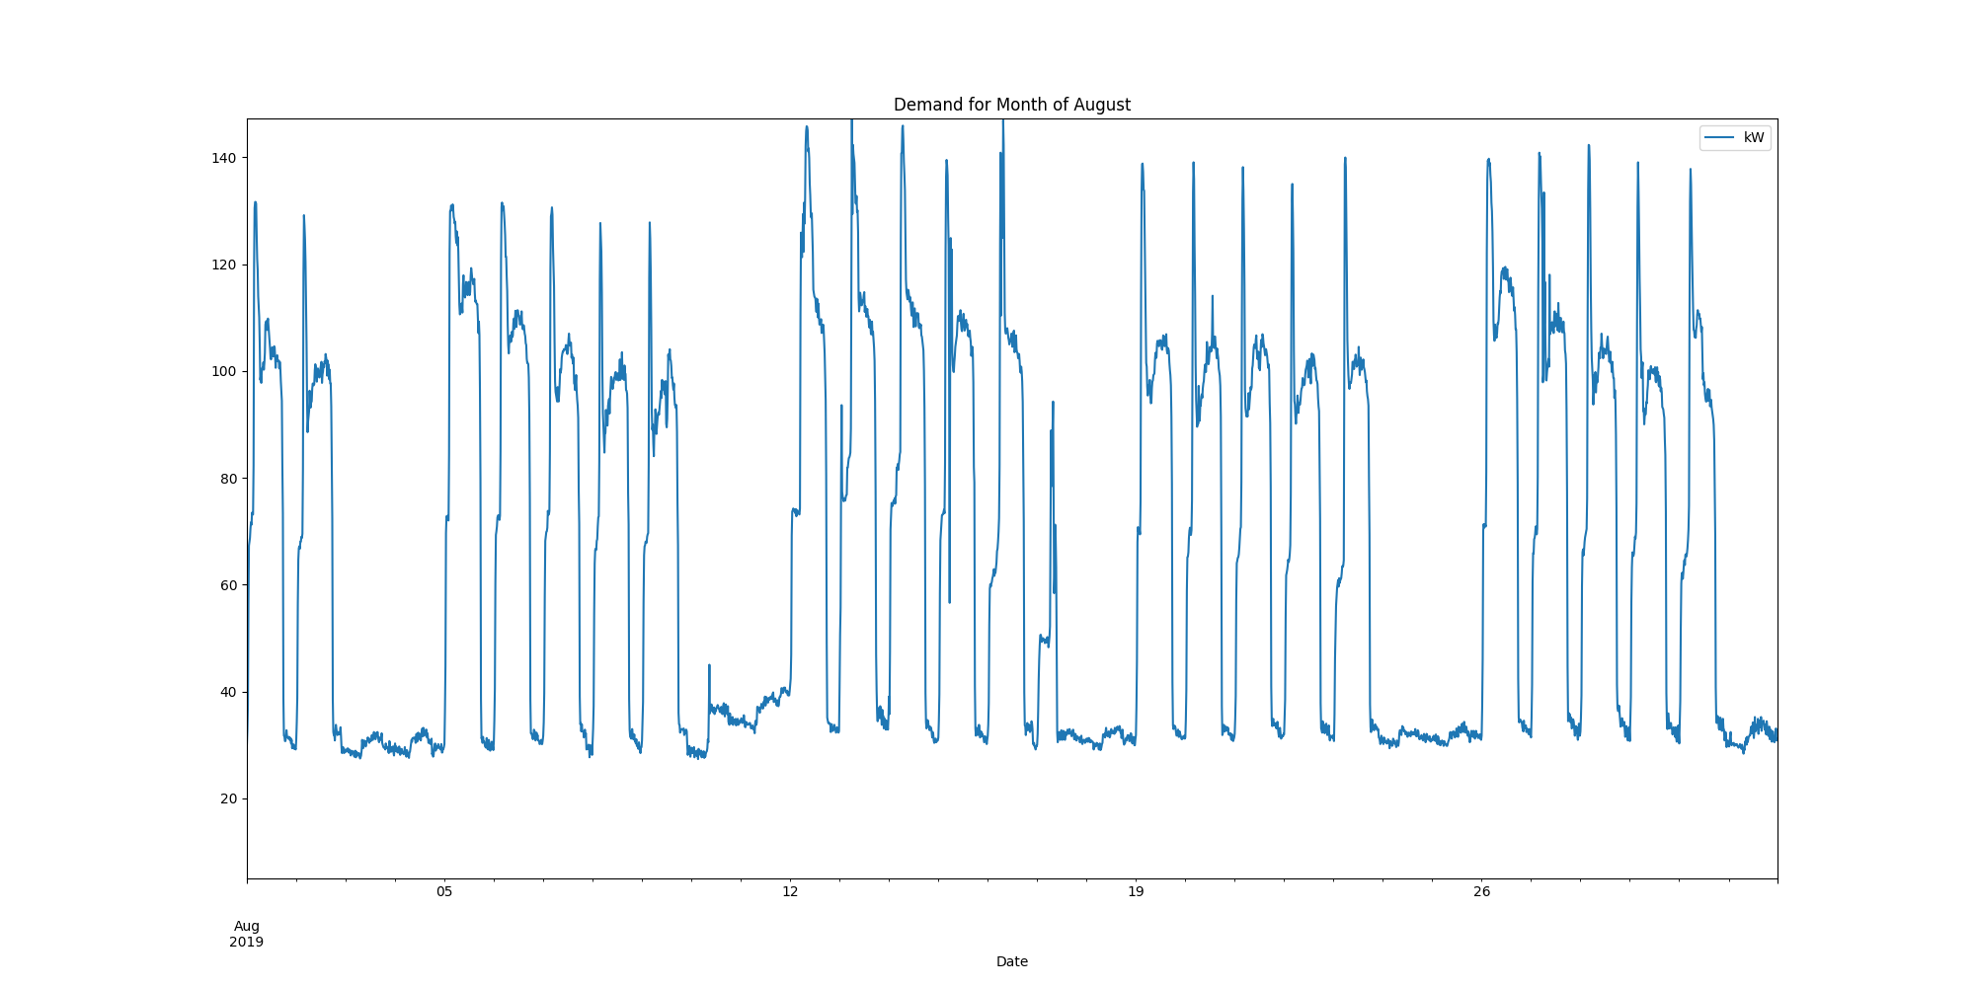

Demands_for_Summer_Month_July.png

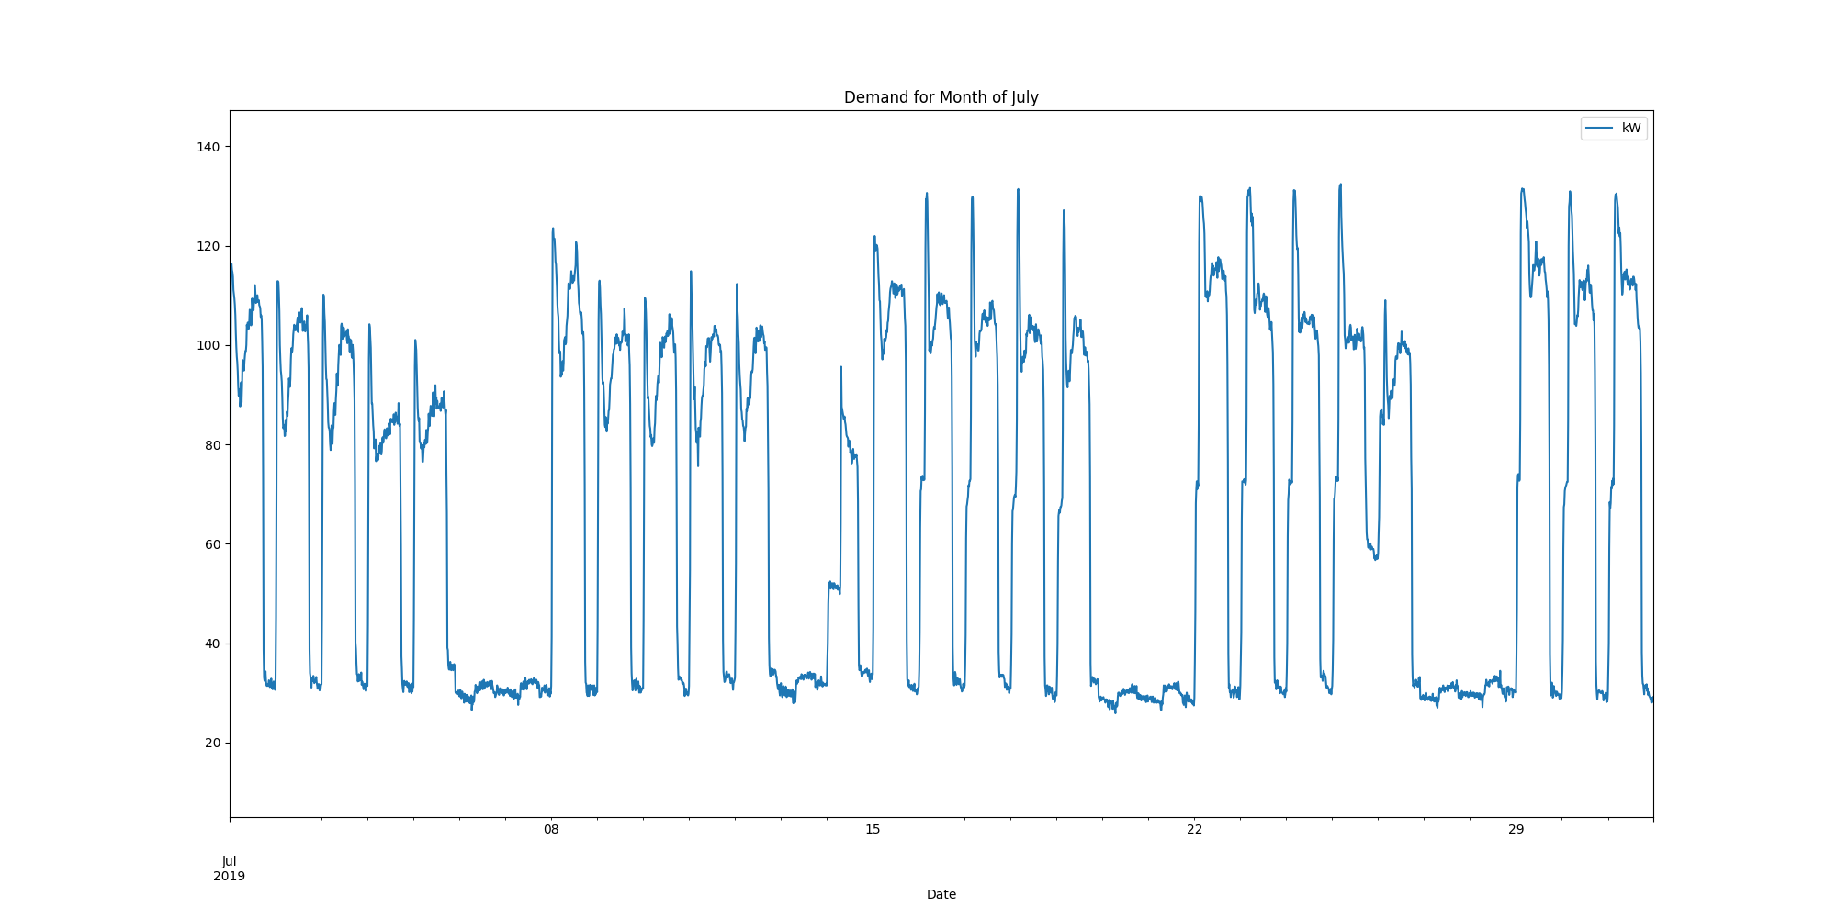

Demands_for_Summer_Month_June.png

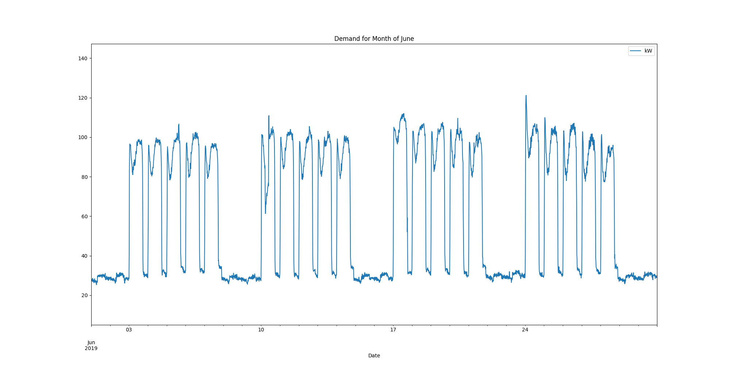

report compiled on:

08/04/2021 09:41:33